DEVELOPMENT OF A PATIENT RECORD MANAGEMENT SYSTEM WITH APPOINTMENT SCHEDULING FOR WELLCARE CLINICS AND LABORATORY – Walter Dasmariñas Branch

AN UNDERGRADUATE CAPSTONE PROJECT

Presented to the Faculty of the
Institute of Computing and Digital Innovation
Kolehiyo ng Lungsod ng Dasmariñas
City of Dasmariñas, Cavite, Philippines

In Partial Fulfillment
of the Requirements for the Degree
Bachelor of Science in Information System

DANAO, ALIYHA MIKAYLA E.
MELCHOR, LHENNY V.
PARPAN, HAZEL ANN J.

FEBRUARY 2026

CHAPTER 1
INTRODUCTION

This chapter will establish the context and rationale of the study, clearly defining the research problem, objectives, and scope, while emphasizing its relevance and alignment with institutional and ethical research standards.

The healthcare sector in the Philippines continues to experience several challenges that affect the accessibility, efficiency, and quality of services provided to patients. There is an ongoing shortage of healthcare professionals, increasing medical expenses, and high out-of-pocket costs that place financial pressure on many individuals. In addition, the gap between healthcare services in urban and rural areas makes it harder for some patients to receive timely and continuous treatment. According to the World Health Organization (World Health Organization: WHO. (2025, December 5). Universal health coverage (UHC)), improving healthcare systems through better service delivery and stronger workforce support is essential in achieving improved health outcomes.
Another major concern is the continued use of manual and paper-based record systems in many healthcare facilities. These traditional processes often result in misplaced files, delayed transactions, incomplete patient histories, and difficulty in accessing laboratory results or medical diagnoses. According to the World Bank, digital health technologies can strengthen healthcare systems by improving efficiency, enhancing data management, and expanding access to services. The adoption of digital solutions allows healthcare providers to make better decisions and deliver more organized and patient-centered care.
Supporting these claims, Griffin et al. (2021)state that patient portals enhance communication between patients and healthcare providers, increase patient satisfaction, and promote active participation in managing one’s health. Likewise, Omokanye et al. (2025) explain that manual record-keeping systems are highly prone to human errors such as illegible handwriting, misfiled documents, and inaccurate documentation, which may negatively affect patient safety and data reliability.
Given these issues, there is a strong need to develop a Patient Record Management System that enables secure storage of patient information, allows patients to view their laboratory results and diagnoses online, virtual consultations, and provides an appointment booking feature. By integrating these functions into one digital system, healthcare facilities can improve workflow efficiency, minimize errors, and provide faster and more convenient services to patients. This system can contribute to better healthcare management and improved patient experience overall.

Project Context
Wellcare Clinics & Laboratories, Inc. is a private healthcare provider offering laboratory services, medical consultations, and diagnostic procedures. The clinic serves a diverse population, including working professionals, students, senior citizens, and patients under Health Maintenance Organizations (HMOs), most of whom seek accessible and timely healthcare within their community. The institution was established in January 1996 in Cavite by alumni of De La Salle Medical and Health Sciences Institute, including Allan S. Hernandez, Ephraim Francisco, Concepcion Carlos, Soledad Crisostomo, Jesus Ambat, and Vicente Caluag. It became one of the pioneers of mall-based healthcare services in the area. In 1998, the clinic expanded its diagnostic capabilities after merging with Mediserv, Inc., originally located at WalterMart Dasmariñas. As of 2025, the organization operates multiple branches across Cavite, including Dasmariñas and Carmona, with Allan S. Hernandez serving as Managing Director.
At present, the clinic relies heavily on manual and outdated processes. Patient records and laboratory results are stored in paper-based files and basic digital tools like manual log book and excel file, making retrieval slow and inefficient. Appointment bookings are managed through SMS or email and require manual confirmation. Although HMO approvals such as Letters of Authorization (LOA) are processed, the lack of system integration limits workflow efficiency.
These conditions create several operational problems. Patients experience delays in receiving laboratory results, difficulty accessing medical records, and overcrowding due to scheduling inefficiencies. A recurring issue is the late arrival of physicians and doctors, which causes patient accumulation in the waiting area despite completed administrative requirements. Misplaced or incomplete records further increase inconvenience and potential medical risks.
To address these issues, the proposed system aims to develop a web-based patient record management with appointment scheduling to Wellcare Clinics and Lab— Waltermart Dasmarñas Branch. The platform will allow patients to securely access laboratory results and medical records, book appointments online, track LOA status, and communicate with providers through a virtual consultation . By automating and integrating key processes, the system seeks to reduce manual errors, improve workflow efficiency, minimize waiting times, and enhance overall patient satisfaction and service quality.

Objectives of the Study

General Objectives

To design a web-based system that is easy for users to understand and operate, this study focuses on the development and implementation of a Web-Based Patient Record Management System with Appointment Scheduling for Wellcare Clinics and Laboratory – WalterMart Dasmariñas Branch. The system improves the management of patient records, simplifies the appointment booking process, and enhances the overall efficiency of clinic operations by replacing manual processes with a more organized and accessible digital system.
Specific Objectives
1. Design the Web-Based Patient Record Management System with Appointment Scheduling that is capable of:
1.1 Providing a user login functionality to ensure data security and role-based access for staff and administrators.
1.2 Managing a dashboard for a comprehensive overview of patient records, appointments, laboratory results and Loa status.
1.3 Creating user roles to define access levels and responsibilities within the system.
1.4 Developing forms for efficient data entry, storage, retrieval and LOA processing of patient and laboratory information.
1.5 Integrating analytics tools for tracking and analyzing patient trends, appointment data, clinic performance and LOA requests.
1.6 Monitoring and tracking Letters of Authorization (LOA) requests and approval status for patients under HMO coverage.
2. Developing the system using software requirements: Laravel Framework (PHP), React Typescripts, HTML, CSS, and MySQL Database.
3. Testing the system’s responsiveness and functionality using hardware requirements: Intel Core i3 (5th Gen or higher), minimum 8GB RAM, 128GB SSD or 500GB HDD, Windows OS.
4. Evaluating the system using ISO 25010 standards to ensure quality, usability, and performance.
5. Preparing an implementation plan for deployment, including user training and strategies for transitioning from the existing manual process.

Purpose and Description

The Development of a Patient Record Management System with Appointment Scheduling for Wellcare Clinics and Laboratory – WalterMart Dasmariñas is designed to improve the current management of patient records and appointment booking at Wellcare Clinics and Laboratory - WalterMart Dasmariñas. The clinic currently relies on manual and paper-based processes, which often result in unorganized patient files, misplaced or lost records, delays in retrieving laboratory results, and congested lines due to inefficient scheduling. These problems affect the quality of service and create inconvenience for both patients and healthcare providers.
The main purpose of this project is to develop a secure, web-based system that will replace the existing manual processes with a digital platform. This study is necessary because the increasing demand for healthcare services requires a more efficient and reliable way of managing patient information. Manual systems are prone to human error, data loss, and slow processing time, which can negatively impact patient care. By conducting this research, the proponents aim to provide a practical solution that enhances efficiency, accuracy, and data security within the clinic.
The proposed system will allow organized storage of patient records, secure online access to laboratory results, and a convenient appointment scheduling feature. Patients will be able to view their medical records and book appointments based on available schedules without the need to physically visit the clinic just to inquire. This will help reduce long queues and improve overall workflow. At the same time, healthcare providers will have quicker access to accurate patient data, enabling them to deliver better and more informed medical care.
The benefits of this study include improved service efficiency, reduced risk of lost files, better communication between patients and healthcare providers, and enhanced patient satisfaction.
Overall, this project has practical applications in modernizing clinic operations and supporting the transition toward digital healthcare solutions. By implementing this system, Wellcare Clinics and Laboratory – WalterMart Dasmariñas can provide faster, more organized, and more secure healthcare services to its patients.
Wellcare Clinics and Laboratory - WalterMart Dasmariñas will benefit from this system by improving the overall quality and efficiency of its services. The development of an accessible patient record management system will help prevent the loss and misplacement of files and ensure a more organized compilation of patient records. The integrated appointment scheduling feature will reduce long waiting lines and improve daily workflow operations. As a result, the clinic can provide faster, more reliable, and more professional healthcare services.
Patients will benefit from the system through added convenience and accessibility. They will be able to view their laboratory test results and medical records online without the need to physically visit the clinic unless necessary. The appointment scheduling feature will allow them to book consultations based on their preferred and available schedules, reducing waiting time and improving their overall healthcare experience.
Staff nurses will benefit from faster and easier access to patient information. Instead of manually searching for paper records, they can quickly retrieve accurate and updated patient data through the system. This will help them perform their tasks more efficiently, reduce documentation errors, and focus more on patient care rather than administrative work.
Doctors will benefit from having organized, complete, and easily accessible patient records. With accurate digital records and laboratory results readily available, they can make faster and more informed medical decisions. This improves diagnostic accuracy, treatment planning, and overall quality of care provided to patients.
Researchers, This study can serve as a reference for researchers who are interested in healthcare information systems and digital transformation in small to medium-sized clinics. It provides insights into how implementing a web-based system can improve efficiency, security, and service delivery in a clinical setting.
Future researchers may use this study as a foundation for further improvements and innovations. They can enhance the system by adding more advanced features, improving security measures, or integrating it with other healthcare technologies. This research may also guide similar system development projects in other healthcare institutions.

Conceptual Framework

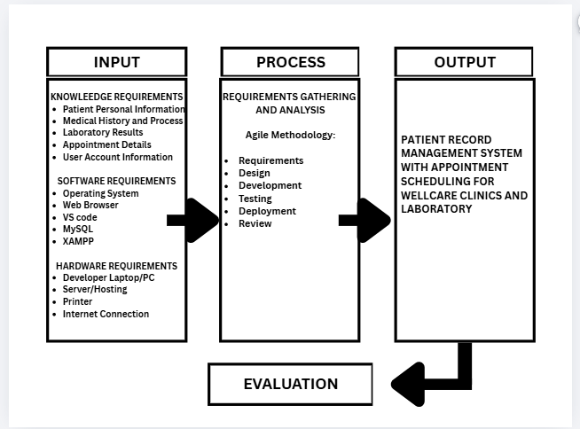

Figure 1. Conceptual Framework of “Development of a Patient Record Management System with Appointment Scheduling for Wellcare Clinics and Laboratory – WalterMart Dasmariñas”

The input represents the necessary data and technical resources required for the development of the system. It includes patient-related information such as personal details, medical history, laboratory results, appointment records, and user account data which serve as the core information to be managed by the system. The development of the system is supported by software tools such as the operating system, web browser, Visual Studio Code, and MySQL for database management. In addition, hardware components including a development computer, server or hosting environment, printer, and internet connectivity are required to support both system development and system accessibility.
The process describes how the gathered inputs are systematically transformed into a working system through the Agile development approach. The development begins with requirements gathering and analysis to determine the operational needs of the clinic. These requirements guide the design and development of the system features. During the development stage, testing is conducted to identify issues and ensure that the system performs according to the intended functions. After successful testing, the system is deployed for implementation, followed by a review phase to evaluate its performance and identify possible improvements.
The output refers to the results achieved after completing the system development process. The proposed system provides a web-based platform that organizes patient records in a structured digital format. It allows secure management of laboratory results and supports online appointment scheduling for patients. Through these functions, the system helps improve the efficiency of clinic operations, minimize delays in accessing patient information, and support more organized handling of medical records.
This conceptual framework demonstrates how essential knowledge and technical resources serve as inputs that undergo a systematic development process using Agile methodology. This process focuses on addressing specific challenges in manual patient record management, appointment scheduling, and LOA processing by creating a web-based system designed to improve efficiency and reduce delays. The framework highlights the transformation from identifying problems to delivering a solution that organizes data better, streamlines appointments, and enhances workflow. Finally, the evaluation component measures the system’s effectiveness and usability, ensuring it meets the clinic’s needs and improves operational performance.

Scope and Limitations

Main Scope of the Study
This study focuses on the development of a Patient Record Management System with Appointment Scheduling designed to improve selected operational processes within the clinic that are currently handled manually. The system aims to address issues such as delayed patient data retrieval, disorganized or misplaced records, appointment congestion, overlapping schedules, prolonged patient waiting times, and slow processing of Letters of Authorization (LOA).
The proposed system digitizes patient records, laboratory results, appointment scheduling, and LOA monitoring to support more organized data management and more efficient clinic operations. In particular, the system incorporates LOA recording, monitoring, and status tracking to help streamline approval verification and reduce administrative delays. Through these features, the system intends to improve record accessibility, scheduling coordination, and overall workflow within the clinic.
The scope also includes the functions and interactions of the following system users:
Patients The system allows patients to create an account, view their medical records and laboratory results, and book or manage their appointments online. They can also check the status of their LOA and receive basic notifications regarding their schedules. In some cases, a user may act as a guarantor or representative of a patient, such as a family member assisting someone who is not technologically adept. In this setup, the guarantor can create and manage the account, while the patient’s actual information is used when filling out appointment and medical forms to ensure accuracy of records.
Staff nurses can access and update patient records, upload laboratory results, and monitor daily appointments. Their scope focuses on supporting clinical tasks by ensuring accurate and updated information within the system.
Admin and HR staff are responsible for managing user accounts, overseeing appointment schedules, and updating LOA records. They ensure that patient data, system activities, and daily operations are organized and properly monitored.
Doctors can access complete patient records, view laboratory results, and document consultations. Their scope includes using the system to review patient information and provide diagnoses more efficiently. Each doctor has a limited schedule of up to five patients per day. When patients book an appointment, they can only see the doctor’s available time slots, which reflect the doctor’s actual availability. If the doctor is not available on a selected date or time, the booking option is disabled and cannot be clicked.
Limitations of the Study
The system is developed specifically for the WalterMart Dasmariñas branch of the clinic and is tailored to its existing workflow and operational structure. Therefore, its design and findings are applicable only to this branch and may require modifications before being implemented in other branches or healthcare facilities.
The study is further limited to evaluating efficiency within patient recording, appointment scheduling, consultation documentation, and LOA monitoring. Other administrative functions such as billing, inventory management, payroll, and accounting are excluded. Although the system improves internal LOA tracking, it does not automate or control approval decisions made by external insurance providers.
Additionally, the system does not account for unforeseen changes in a doctor’s availability, such as being assigned to another clinic or hospital, or sudden events that may lead to the cancellation of scheduled appointments. These situations are beyond the scope of the system and are not managed or automated within its functionality.

Definition of Terms
This section presents the definition of key terms used in the study to provide clarity and a better understanding of the concepts discussed. The terms are defined based on their conceptual and operational meanings as applied in this research.
Appointment Booking This refers to enabling scheduling meetings or services via web, phone, or apps. In this study, this refers to the system feature that allows patients to schedule consultations or services with doctors at a specific date and time.
Comparative Analysis This refers to a systematic method used to evaluate two or more subjects, datasets, or processes by identifying their similarities, differences, and patterns. In this study, this refers to a method used in the study to compare clinic processes before and after the implementation of the proposed system.
Electronic Health Record (EHR) This refers to a digital version of a patient's comprehensive medical history maintained over time. In this study, this refers to the digital record of a patient’s medical information, including personal details, consultation notes, and laboratory results, stored and managed within the web-based patient record management system for easy access by authorized clinic staff and doctors.
Health Maintenance Organization (HMO) This refers to a managed care insurance plan that provides prepaid, comprehensive medical services through a specific network of doctors and hospitals. In this study, this refers to a health insurance provider that authorizes and covers medical services for patients through approved healthcare facilities.
MySQL This refers to a widely used, free, and open-source Relational Database Management System (RDBMS) that uses Structured Query Language (SQL) to manage and store data. In this study, this refers to the database management system used to store and manage patient and system data.
Operating System (OS) This refers to essential system software that manages computer hardware and software resources, acting as an intermediary between applications and hardware. In this study, this refers to a software that manages computer hardware and supports the operation of the developed system.
Web-based patient record This refers to a digital, secure, and internet-accessible system used by healthcare providers to create, manage, and store patient information like histories, notes, and lab results in real-time. In this study, this refers to a digital system used to store, manage, and access patient medical information through the internet.
XAMPP This refers to a free, open-source, cross-platform web server solution stack that allows developers to create and test websites locally using Apache, MariaDB, PHP, and Perl. In this study, this refers to a local server software used to develop and test the web-based system.

CHAPTER 2
Review of Related Literatures
This chapter will systematically examine and synthesize relevant literature and prior studies, providing a theoretical and conceptual foundation that will support the direction, credibility, and ethical grounding of the research.

Informed or Anxious: Patient Preferences for Release of Test Results of Increasing Sensitivity on Electronic Patient Portals
Bruno et al. (2022) examined patient preferences regarding the release of medical test results through electronic patient portals. The study demonstrated that while many patients value immediate access to their laboratory results for convenience and transparency, reactions differ depending on the sensitivity of the information. The researchers found that patients are generally comfortable viewing routine or less serious results online; however, when results are highly sensitive or potentially serious, many prefer to receive them directly from a healthcare provider. This preference is largely due to concerns about anxiety and the need for proper medical explanation. The findings emphasize the importance of designing patient portal systems that balance accessibility with appropriate professional support.

Patient Portals to Support Care Partner Engagement in Adolescent and Adult Populations: A Scoping Review
A scoping review by Irizarry et al. (2023) explored how patient portals can support the engagement of care partners in adolescent and adult populations. The study synthesized findings from multiple research articles to identify patterns and gaps in the use of patient portals for facilitating communication, sharing health information, and involving caregivers in healthcare management. The review revealed that patient portals can enhance transparency and collaboration between patients, care partners, and healthcare providers, but challenges such as privacy concerns and variable portal usability remain significant barriers. By summarizing existing literature, this review provides valuable insights into the potential benefits and limitations of patient portal systems and highlights areas requiring further research to optimize their effectiveness.
A Qualitative Analysis of the Impact of Electronic Health Records (EHR) on Healthcare Quality and Safety: Clinicians’ Lived Experiences
Electronic Health Records (EHR) have become an essential component in improving healthcare quality and patient safety. A qualitative study explored the lived experiences of clinicians who regularly use EHR systems in healthcare settings (Upadhyay & Hu, 2022). The study found that EHR systems improve accessibility to patient information, enhance communication among healthcare professionals, and support accurate documentation of medical records. These advantages contribute to more efficient clinical decision-making and better coordination of patient care. However, several challenges were also identified, including usability issues, complex system navigation, and increased documentation workload for clinicians. Despite these limitations, the study emphasizes that well-designed and user-friendly EHR systems can significantly enhance healthcare delivery and overall patient safety.
Patient portals: A systematic review on patient education and medication management
A systematic review by Kruse et al. (2022) examined existing studies on patient portals to understand how they support patient education and medication management. The review found that patient portals can improve patient knowledge about their medications, facilitate secure communication with healthcare providers, and increase patient engagement in managing their own health. Additionally, portals were shown to contribute to patient safety by helping reduce medication errors. However, the study also highlighted challenges, such as limited portal awareness, usability difficulties, and privacy concerns, which may hinder widespread adoption. Overall, the review emphasizes the potential benefits of patient portals while identifying areas for further research to enhance their accessibility and effectiveness.

Privacy Preservation of Electronic Health Records in the Modern Era: A Systematic Survey
The protection of patient information is a critical concern in the implementation of Electronic Health Record (EHR) systems. A systematic survey examining privacy preservation in EHR environments analyzed more than 130 studies published between 2012 and 2022 to identify the common techniques used to secure healthcare data (Nowrozy et al., 2024). The study highlighted that maintaining privacy, confidentiality, and security is essential when managing digital medical records, as these systems contain sensitive patient information. Various technological approaches such as access control mechanisms, blockchain technology, cloud-based infrastructures, and cryptographic methods are widely utilized to protect EHR data during storage and sharing. The findings also emphasized that the clear distinction between privacy, confidentiality, and security plays an important role in designing effective healthcare information systems. Strengthening these security mechanisms is therefore necessary to ensure that EHR systems can safely support data sharing while protecting patient privacy.
Outpatient Clinic Management System at Adventist Medical Center Bacolod
Junic B Diplomo et al. (2025) The development of an Outpatient Clinic Management System at Adventist Medical Center Bacolod aimed to shift from a paper-based process to a hybrid web-based and desktop-based system. The study found that the system improved workflow efficiency, enhanced patient record management, and reduced manual errors by digitizing services such as appointment scheduling, consultation, and recordkeeping. The researchers also noted challenges such as resistance to change, need for user training, and data security concerns. Despite these limitations, the system proved effective in improving clinic operations and supporting better administrative decision-making. This study demonstrates the importance of digital systems in enhancing healthcare service delivery in local clinical settings.
Clinicord: A Web and Mobile Scheduling System for Medical Clinics in Olongapo City Using Progressive Web App Frameworks
Sanchez et al. (2022) developed Clinicord, a web and mobile scheduling system for medical clinics in Olongapo City using Progressive Web App frameworks. The system aimed to support healthcare facilities during limited face-to-face interactions, such as lockdowns. Using an Agile Scrum development methodology, the project created a dual-platform solution: a website for admins and receptionists and a mobile application for doctors and patients. Evaluation following the ISO-25010 software standard rated the system as “Highly Acceptable.” The study demonstrated improvements in appointment handling, report generation, and workflow efficiency, highlighting the role of integrated web and mobile technologies in modernizing local healthcare service delivery.

PHIrecord: a medical record management system for rural health facilities in the Philippines
Orpiada et al. (2024) highlighted the limitations of paper-based recordkeeping in rural Philippine health facilities and proposed a digital medical record management system called PHIrecord. The system provides centralized storage of patient information, secure access for both healthcare providers and patients, referral management, and digital prescription handling. These features significantly enhance operational efficiency, reduce data duplication, and improve patient tracking within healthcare facilities. This study supports the need for digital transformation in managing medical records, particularly in local clinic settings.
Exploring the landscape of health information systems in the Philippines: a methodical analysis of features and challenges
Tinam-isan (2024). Conducted a comprehensive analysis of Health Information Systems (HIS) implemented in the Philippines using the PRISMA approach. From an initial pool of 313 articles, 285 were excluded based on the established criteria, resulting in 28 relevant studies for detailed analysis. The study categorized various features of HIS that contribute to improving healthcare services in the country. These features include scheduling and communication systems, patient record management, prescription handling, knowledge and information management, as well as marketplace and payment services. The findings revealed that common functionalities among most HIS include patient profiling, notification systems, membership verification, laboratory result generation, and electronic appointment scheduling. In addition, the study identified several challenges affecting the implementation of HIS in the Philippines, such as limited human resources, infrastructure constraints, regional policy differences, and financial limitations. The study provides valuable insights into the current landscape of health information systems in the Philippine healthcare sector and highlights important considerations for improving healthcare technology implementation.
Electronic Document Management System (EDMS) Implementation: Implications for the Future of Digital Transformation in Philippine Healthcare
According to Almacen and Cabaluna (2021), the rapid development of digital technologies has significantly influenced various sectors, including healthcare. The transition from traditional paper-based medical records to electronic systems has improved the management and storage of patient information. Early electronic health records were introduced in the 1960s to maintain long-term patient data; however, technological limitations at that time hindered their continued use. With the advancement of modern technologies, healthcare institutions are now gradually adopting digital solutions such as Electronic Document Management Systems (EDMS) to improve the organization, accessibility, and security of patient records. The authors emphasized that proper medical documentation remains a major concern in healthcare management, and implementing digital record systems can enhance the consistency and reliability of patient data. In the Philippine healthcare setting, adopting electronic systems may help address issues related to record management and support the improvement of healthcare services.
Development and Implementation of a New Patient Appointment Scheduling System at Adustech Wudil: an Evaluation of User Satisfaction and System Impact:
Yarima et al. (2024) developed a computerized Patient Appointment Scheduling System to address inefficiencies in the traditional manual scheduling process at Aliko Dangote University of Science and Technology, Wudil. Their system, built using HTML, PHP, CSS, JavaScript, and MySQL, was designed to enhance patient registration, appointment booking, and session scheduling. The researchers reported significant improvements, including a 92% increase in overall system performance, a 90% rise in staff productivity, and a 90% reduction in patient waiting time. These findings highlight the substantial impact of digitizing clinical scheduling processes and demonstrate how automated systems can streamline healthcare service delivery.
A conceptual framework to ensure privacy in patient record management system
In their 2021 study, Farida Habib Semantha, Sami Azam, Bharanidharan Shanmugam, Kheng Cher Yeo, and Abhijith Reddy Beeravolu conducted an extensive examination of privacy concerns within Patient Record Management Systems (PRMS) and emphasized the growing risks associated with handling sensitive health information. Their work, published in IEEE Access, reviewed existing privacy-preserving frameworks and identified persistent security gaps in safeguarding patient data. To address these limitations, the authors proposed a comprehensive three-phase conceptual framework. The first phase focuses on identifying privacy weaknesses in current systems; the second incorporates essential data protection components to strengthen framework efficiency; and the third phase outlines implementation strategies to mitigate privacy breaches. Their findings reveal that although various studies discuss healthcare data security, a complete privacy-by-design solution ensuring protection across all layers of a PRMS remains scarce. This study provides significant relevance to the development of patient record and appointment scheduling systems, as it highlights the need for robust, multilayered privacy architecture to secure sensitive clinical information effectively.
The role of personality and top management support in continuance intention to use electronic health record systems among nurses
In their 2022 study, Adi Alsyouf, Awanis Ku Ishak, Abdalwali Lutfi, Fahad Nasser Alhazmi, and Manaf Al-Okaily investigated the continuance intention of nurses to use Electronic Health Record (EHR) systems by integrating three established frameworks: the Unified Theory of Acceptance and Use of Technology (UTAUT), Expectation-Confirmation Theory (ECT), and the Five-Factor Model (FFM). Published in the International Journal of Environmental Research and Public Health, their research analyzed survey data from 497 nurses using partial least squares modeling to identify psychological, organizational, and behavioral predictors of continued EHR usage. The findings revealed that performance expectancy significantly mediated relationships between personality traits—particularly agreeableness and openness—and continuance intention, while conscientiousness moderated key Unified Theory of Acceptance and Use of Technology (UTAUT) pathways. Although top management support showed no direct influence, the authors emphasized that personality-aware design and institutional support remain crucial for sustained system use. This study offers valuable insights for the development of patient record and appointment scheduling systems, highlighting that successful digital health implementations depend not only on system functionality but also on user characteristics, perceived usefulness, and organizational environment.
Impact of information system integration on the healthcare management and medical services
Wu, Z., & Trigo, V. (2021) the integration of information systems in healthcare significantly improves management efficiency, service quality, and patient safety. Information Systems (IS) integration refers to the degree to which data and applications are shared across communication networks to ensure smooth and real-time access to medical information. The study emphasizes that complete and consistent healthcare data enhances diagnosis and treatment processes. It also highlights the importance of technologies such as cloud computing, Internet of Things (IoT), data analytics, and blockchain in ensuring secure and efficient data sharing. The findings suggest that although challenges exist, the promotion and development of IS integration in healthcare institutions are essential. This supports the present study, as the proposed Patient Record Management System with Appointment Scheduling aims to improve data accessibility, operational efficiency, and overall healthcare service delivery at Wellcare Clinics and Laboratory – Walter Dasmariñas Branch.
A secure and cloud-based patient management system using attribute-based encryption algorithm
Kalarani et al. (2025) proposed a secure cloud-based patient management system using an attribute-based encryption (ABE) algorithm to enhance healthcare data security and efficiency. The study emphasized scalable encryption infrastructure, dynamic attribute handling, and context-aware access control to ensure secure data sharing. It also highlighted advanced key management, real-time auditing, and monitoring mechanisms to prevent unauthorized access and protect patient privacy. The system was implemented using cost-effective cloud and open-source technologies to ensure operational effectiveness in healthcare environments. This study is relevant to the present research because the proposed Patient Record Management System with Appointment Scheduling for Wellcare Clinics and Laboratory – Walter Dasmariñas Branch also aims to securely manage patient records and improve healthcare service delivery through a reliable and protected digital platform.

Outpatient Department Clinic Management System at Adventist Medical Center Bacolod
According to Rodelio Diplomo and Rex Pomperada (2025), the development of an outpatient department clinic management system helps improve the management of patient information and clinic operations. The study emphasized the importance of implementing computerized systems in healthcare facilities to reduce manual record keeping and improve efficiency in handling patient data. Through the use of a digital system, clinic staff can organize patient records, monitor clinic transactions, and manage healthcare services more effectively. The findings indicate that adopting a clinic management system enhances workflow efficiency, improves data accuracy, and supports better healthcare service delivery. This study is relevant to the present research because the proposed Patient Record Management System with Appointment Scheduling for Wellcare Clinics and Laboratory – Walter Dasmariñas Branch also aims to improve patient record management and clinic operations through a computerized system.
E-Konsulta: Clinic Medical Record Management System with Online Follow-Up Through Google Meet
According to Rodel Cadingilan et al. (2025), the development of the E-Konsulta clinic medical record management system aims to improve the management and accessibility of patient medical records in healthcare facilities. The study emphasized that traditional manual record-keeping systems often lead to inefficiencies, data redundancy, and difficulty in retrieving patient information. By implementing a computerized medical record management system, clinics can organize patient data more efficiently, improve record accuracy, and enhance the overall workflow of healthcare providers. The system allows healthcare personnel to easily store, access, and manage patient records, which helps improve service delivery and operational efficiency. This study supports the present research because the proposed Patient Record Management System with Appointment Scheduling for Wellcare Clinics and Laboratory – Walter Dasmariñas Branch also aims to digitize patient records and improve clinic operations through a reliable and efficient information system.
User Acceptance of Electronic Health Records in the Philippines
A study conducted by De Mesa et al. (2024) examined the acceptance of electronic health record systems among healthcare workers in urban, rural, and remote healthcare facilities in the Philippines. The findings revealed that healthcare workers generally support the use of EHR systems because they make it easier to access patient data and improve healthcare service delivery.
Implementing Electronic Health Records in Philippine Primary Care Settings
A study by Elepaño et al. (2025) examined the implementation of electronic health record systems in several primary care facilities across urban, rural, and remote areas in the Philippines. The study found that EHR systems help healthcare providers manage patient data more efficiently by integrating clinical documentation, laboratory records, and reporting modules. The research also showed that digital systems support better access to patient information and improve coordination of healthcare services.
MedSched: Digitalizing health process and automating services
According to Osiang et al. (2026), a web-based healthcare system called MedSched was developed to automate appointment scheduling and manage patient medical records for a rural health unit in the Philippines. The system allows patients to schedule appointments online while enabling healthcare personnel to efficiently manage patient information and schedules. The findings of the study revealed that the implementation of the system improved service efficiency, minimized manual processes, and enhanced communication between patients and healthcare providers. This study supports the importance of digital healthcare systems in improving clinic operations and patient service delivery.
Patient Appointment Scheduling System
According to Kamaluddeen Ibrahim Yarima et al. (2024), the development of a patient appointment scheduling system improves healthcare service delivery by allowing patients to register and book consultations through a computerized platform. The system replaces traditional manual scheduling methods with a web-based application developed using HTML, PHP, CSS, JavaScript, and MySQL. The results showed that the system improved clinic productivity and significantly reduced patient waiting time. This related system supports the present study because it demonstrates how digital appointment scheduling can enhance efficiency in healthcare services. Similarly, the proposed Patient Record Management System with Appointment Scheduling aims to provide an organized and automated platform for managing patient appointments and records at Wellcare Clinics and Laboratory.
Doctor-Patient Appointment Management System
Raj Kumar S. et al. (2024) developed a web-based doctor-patient appointment management system designed to improve healthcare accessibility and administrative efficiency. The system allows patients to search for available doctors, view schedules, and book appointments online through a user-friendly interface. It also sends automated reminders to both patients and doctors to avoid missed consultations. The study highlights how digital scheduling systems improve communication between patients and healthcare providers. This related system is relevant to the present research because it demonstrates how automated appointment management can improve healthcare services, which aligns with the objective of integrating appointment scheduling into the proposed patient record management system.
MyHealthPortal (E-Healthcare Portal System)
MyHealthPortal is a web-based healthcare system designed to improve access to medical services and patient information through an online platform. The system allows patients to register online, schedule appointments, and access their health records such as diagnoses and laboratory results. By digitizing these processes, the system helps reduce reliance on manual record-keeping and improves efficiency in managing patient data. According to a study available in the National Center for Biotechnology Information, web-based healthcare portals can improve healthcare service delivery by allowing patients to access medical information remotely and communicate more effectively with healthcare providers.
LifeDoc: Availability and Monitoring System of Online Medical Consultation
Caballero et al. (2021) developed LifeDoc, a mobile-based system designed to provide online medical consultation services for both patients and doctors. The system integrates the Information Technology Infrastructure Library (ITIL) framework, specifically Availability Management and Event Monitoring, to ensure reliable and efficient healthcare services. The application was developed using React Native and WebRTC, while patient data and system information were securely stored in a MongoDB cloud database. The researchers applied the Agile development methodology and conducted system testing based on IEEE (Institute of Electrical and Electronics Engineers) software testing standards to ensure that the system functions according to its specifications. The study highlights how integrating digital technologies into healthcare systems can improve the accessibility and efficiency of medical services. This system is related to the present study as it demonstrates the use of digital platforms in managing healthcare services and patient interactions, which supports the development of a web-based patient record management system with appointment scheduling.
Implementing an integrated electronic outcomes and electronic health record process to create a foundation for clinical practice improvement
This study described the integration of electronic functional status outcomes into an EHR to enhance clinical practice improvement. Data from 21,523 adult patients across 11 outpatient physical therapy clinics were collected using computerized adaptive testing and integrated into the EHR. Key measures included participation rate (79.8%), completion rate (45.1%), and average data entry time per patient (3 minutes 37 seconds). Administrative burden was minimal (maximum 9.6% of episode time). Findings suggest that routine outcomes data collection is feasible, can be effectively incorporated into EHRs, and supports clinical evaluation and outcomes research.
Category | Key Insights | Theories/Concepts | Interralation | Support to Reaserch Objectives | Gap/Trends Idenified
Foreign Literature | Patient portals improve communication and information sharing among patients, care partners, and healthcare providers. | Health information accessibility and transparency, Health information accessibility and transparency  Usability and privacy in patient portal systems | connects patient portals, caregiver participation, and healthcare communication, showing how digital platforms can strengthen collaboration while emphasizing the need to balance accessibility with privacy and system usability. | support the objective of developing a Patient Record Management System with Appointment Scheduling by demonstrating how digital systems enhance information sharing, collaboration, and healthcare coordination. | Need for improved portal usability and user-centered design  Ongoing privacy concerns when sharing sensitive patient information
Local Literature | Local studies reveal that digital healthcare systems improve patient data management, accessibility, accuracy, and service efficiency by replacing manual processes | Electronic Health Records (EHR), Health Information Systems, System Automation, Appointment Scheduling Systems | Demonstrates the connection between centralized records, automated processes, and improved healthcare coordination, showing how digital platforms enhance information sharing, reduce errors, and streamline patient flow | Supports the development of a Patient Record Management System with Appointment Scheduling by emphasizing the need for integrated, efficient, and accessible healthcare solutions | Limited usability and user-centered design, lack of full integration between records and scheduling, and ongoing concerns on data privacy, security, and system adoption in local settings
Foreign Studies | Digital healthcare systems improve efficiency, reduce waiting time, and increase productivity. User acceptance and data privacy are also important. | Technology acceptance, user behavior, and system usability; data privacy and security in patient record systems; and integration of healthcare information systems for real-time data access. | The studies show that appointment scheduling and record management systems are more effective when integrated, user-friendly, and secure, linking system performance with user acceptance. | Supports the development of a patient record management system with appointment scheduling by showing how digital systems improve efficiency and healthcare services. | Need for stronger data privacy, better user-centered design, and improved overall system usability.
Local Studies | Computerized clinic systems improve patient record management, data accessibility, and workflow efficiency. Healthcare workers also show positive acceptance of digital record systems. | Digital transformation of healthcare systems; electronic health record adoption; and system usability in managing patient data and clinic operations. | The studies show that implementing electronic record systems improves data management, accessibility, and service delivery while supporting better workflow and user acceptance. | Supports the development of a patient record management system with appointment scheduling by showing how digital systems improve clinic operations and healthcare services. | Need for improved user training, better system implementation, and continuous enhancement of digital healthcare systems.
Related Systems | Enables online patient registration appointment scheduling, and access to health records (e.g., diagnoses, lab results). | Digital transformation of medical record management  Patient engagement through web-based platforms | integrates patient record access and appointment scheduling into a single web platform, linking digital record management with improved communication and service accessibility. | supports how a web-based portal can centralize patient records and scheduling functions, aligning with the goal of developing a Patient Record Management System with Appointment Scheduling. | Limited discussion on data privacy and security mechanisms  Need for usability optimization for diverse users

Synthesis
The reviewed literature emphasizes the significant role of digital health technologies in improving healthcare management, particularly in patient record management, appointment scheduling, and access to medical information. Several foreign studies highlight how electronic systems such as patient portals and Electronic Health Records (EHR) enhance patient engagement, improve communication between healthcare providers and patients, and support more efficient clinical decision-making. Research conducted by Bruno et al. (2022), Irizarry et al. (2023), and Upadhyay and Hu (2022) demonstrates that digital platforms contribute to transparency, accessibility of patient data, and improved coordination of healthcare services. In addition, studies highlight the importance of maintaining privacy, security, and proper system integration to ensure the safe and effective use of electronic health systems (Nowrozy et al., 2024; Wu & Trigo, 2021).
Similarly, local literature and studies demonstrate the growing adoption of digital healthcare systems in the Philippines to address the limitations of traditional paper-based processes. Research shows that clinic management systems, electronic medical records, and scheduling platforms significantly improve workflow efficiency, reduce manual errors, and enhance patient information management (Diplomo & Pomperada, 2025; Sanchez et al., 2022; Orpiada et al., 2024). However, challenges such as infrastructure limitations, financial constraints, and the need for proper training remain factors affecting the implementation of health information systems in the country (Tinam-isan & Naga, 2024). Overall, the reviewed literature supports the development of a Patient Record Management System with Appointment Scheduling, as digital solutions have the potential to enhance healthcare efficiency, improve data management, and strengthen the overall delivery of healthcare services.

CHAPTER 3
METHODOLOGY
This chapter will outline the research design, data collection procedures, instruments, and analytical approaches that will be employed, ensuring adherence to ethical guidelines, transparency, and methodological rigor throughout the conduct of the study.

RESEARCH APPROACH
This study adopted a qualitative research approach together with Agile development methodology to ensure a systematic, user-centered, and data-driven development of the Online Patient Record Management with Booking Appointment System. The study focused solely on qualitative data to gain a deeper understanding of user needs, existing challenges, and workflow improvements within the clinic environment.
On the qualitative side, data were gathered through observations and interviews to examine the existing manual processes, identify current issues, and determine the specific needs of the clinic. The study involved interviews, observations, and feedback sessions with healthcare personnel, including staff nurses, front desk personnel, and administrative staff. These methods provided in-depth insights into the limitations of the current paper-based record system and unorganized appointment booking process, such as slow information retrieval, documentation delays, and risks of data inaccuracy. The findings guided the identification of system requirements and informed continuous improvements during each Agile sprint.
By integrating qualitative insights with Agile’s iterative development process, the study ensured that the system was continuously refined based on real user experiences and feedback. This approach provided a structured and user-focused method for developing an efficient, reliable, and responsive Online Patient Record Management with Booking Appointment System.

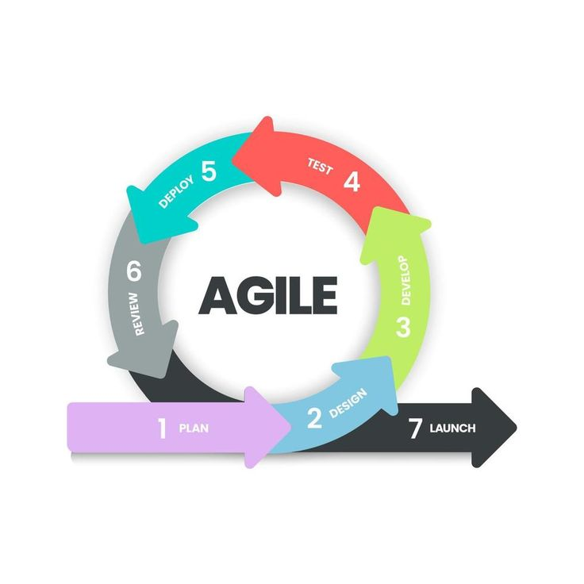
Figure 1 The Agile Methodology Life cycle used in the Development of a patient record management system with appointment booking for wellcare clinics and laboratory- walter dasmarinas branch.
Planning:
In the initial phase, the researchers collaborated to define the system’s objectives, scope, key features, and user requirements. This ensured that the system would effectively address the operational and record-keeping needs of the Online Patient Record Management with Booking Appointment System.
Design:
During the design phase, the researchers created wireframes, system workflows, and database structures. Tools such as Canva were used to visualize the user interface and module layouts, resulting in a clear, organized, and user-friendly system design.
Development:
The system was developed using The system was developed using Next.js with TypeScript as the primary framework. HTML and Tailwind CSS were utilized to create responsive and accessible user interfaces. Firestore (Firebase Database) was employed for backend data storage, retrieval, and management, providing a secure and scalable solution for patient records.
Testing:
After development, the system underwent comprehensive unit, system, and integration testing to verify its functionality, usability, and reliability. Any bugs or technical issues identified were resolved to ensure the system performs efficiently and meets user requirements.
Review:
The researchers presented the developed features to the team, collected feedback, and discussed possible improvements and additional functionalities. This iterative review process ensured that the system aligned with user expectations and project objectives.
Deployment:
Once a stable version was achieved, the system was deployed to a controlled environment for user testing by clinic staff. The deployment process was documented, and all critical data were securely backed up.
Launch:
For the final launch, the completed system will be fully implemented at the Wellcare Health clinics and Lab— WallterMart Branch. User manuals were provided, and training sessions were conducted for staff to ensure smooth operation. System usage was monitored, feedback was collected, and a post-launch report was prepared to evaluate performance, user experience, and identify areas for future improvement.

Requirement Analysis
The requirement analysis for the Patient Record Management System with Appointment Scheduling focuses on replacing the manual, paper-based workflow of the Walter Dasmariñas Branch with a centralized digital system. Currently, patients, nurses, doctors, and administrative staff manage clinic operations manually, including patient registration, appointment scheduling, record keeping, and medical documentation. These processes are done using logbooks and physical files during clinic operating hours, which often result in delays, data redundancy, difficulty in retrieving records, and patient congestion.
The proposed system aims to streamline these processes through a digital platform with user-based functionalities. Patients can register, book appointments, and view medical records and laboratory results. Nurses are responsible for encoding and updating patient data, while doctors can access patient histories, update diagnoses and prescriptions, and conduct consultations, including online consultation features. Administrative or HR staff manage user accounts, monitor schedules, generate reports, and handle Letter of Authorization (LOA) for HMO/Insurance) communications via email with HMO partners.
The system will be developed using Laravel for the backend and React TypeScript for the frontend, supported by a centralized database and real-time dashboard analytics. Overall, the system aims to improve clinic efficiency, reduce manual errors, and enhance healthcare service delivery.
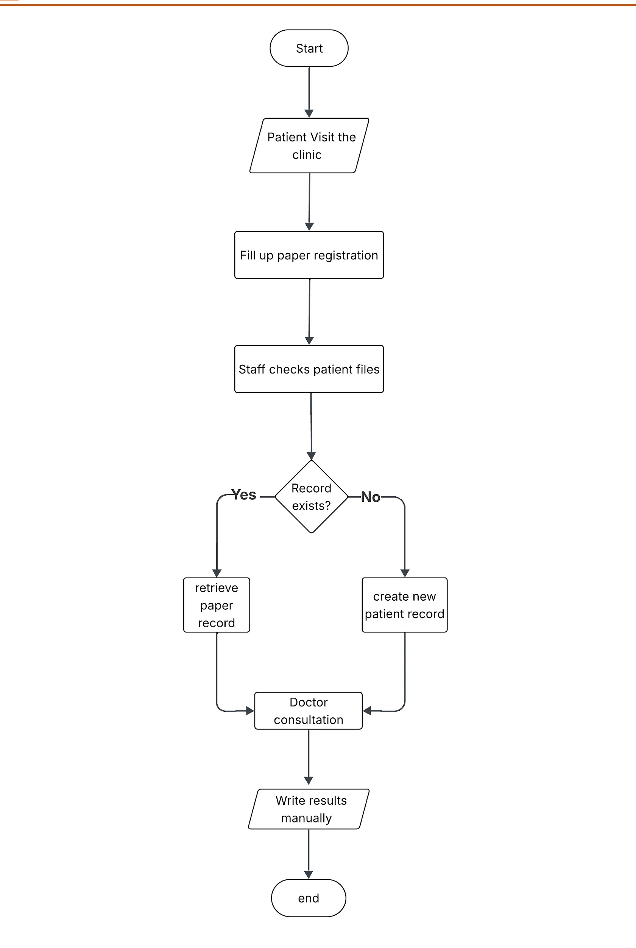

Figure 2 Current Flow for DEVELOPMENT OF A PATIENT RECORD MANAGEMENT SYSTEM WITH APPOINTMENT SCHEDULING FOR WELLCARE CLINICS AND LABORATORY – Walter Dasmariñas Branch

The current system flow begins when a patient visits the clinic and completes a paper registration form. Once submitted, the staff reviews the patient files to verify whether an existing record is already on file. At this decision point, if a record exists, the staff retrieves the patient’s paper record; if no record is found, a new patient record is created. After ensuring that the appropriate record is available, the patient proceeds to the doctor for consultation. Following the consultation, the doctor documents the findings and results manually on paper. The process then concludes, reflecting a fully manual and paper-based workflow from registration to documentation.
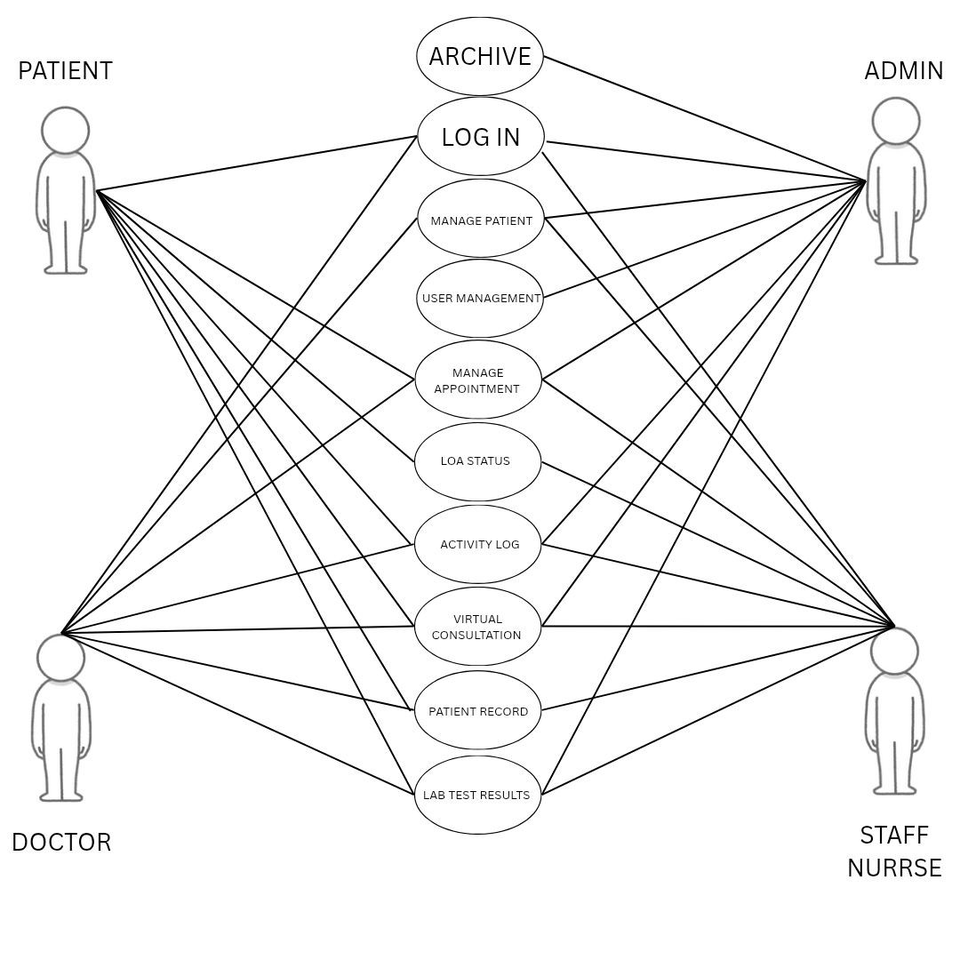

Figure 3 Use Case Diagram for the Development of a patient record management system with appointment booking for wellcare clinics and laboratory- walter dasmarinas branch.
Figure 3 shows the use case diagram illustrates the key interactions between the online patient record management with booking appointment and virtual consultation and its four user roles: System Administrator, Doctor, Patient, and Staff nurse. Each actor accesses specific system functions based on their responsibilities. Common functions such as Login, Manage Patients, Manage Appointments, Activity Log, LOA status, lab test results, patient record,and virtual Consultations are shared across multiple users, while administrative functions—Manage Providers, User Management, and Archive—are primarily accessed by the System Admin. The diagram highlights role-based access, showing how each user performs only the tasks relevant to their role within the clinic’s digital workflow.

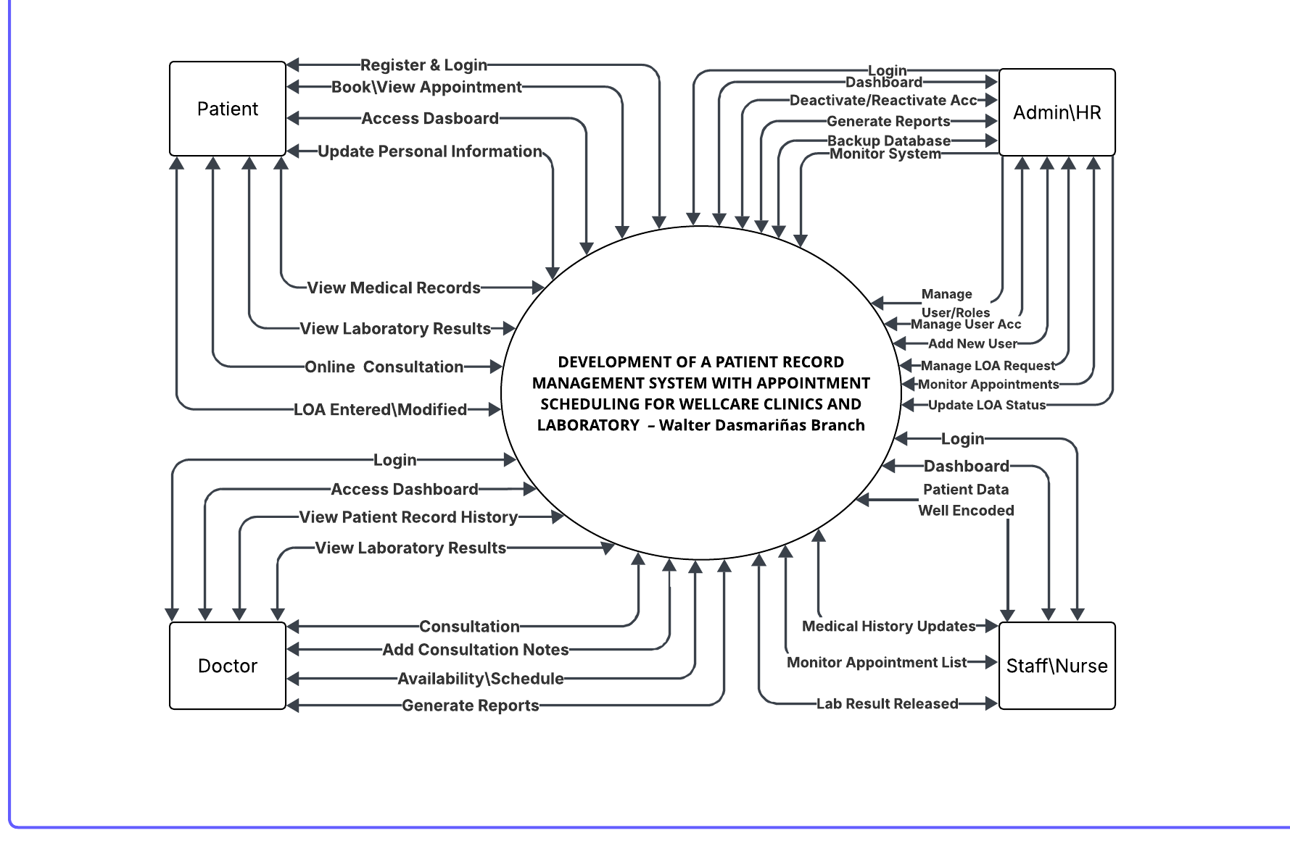
Figure 4 Context Diagram for the Development of a patient record management system with appointment booking for wellcare clinics and laboratory- walter dasmarinas branch.
Figure 4 shows the Context Diagram of the Development of a Patient Record Management System with Appointment Scheduling for Wellcare Clinics and Laboratory – WalterMart Dasmariñas Branch. The diagram presents the overall interaction between the system and its external users, namely the Patient, Doctor, Staff/Nurse, and Admin/HR.
The Patient interacts with the system by performing functions such as registration and login, booking appointments, accessing the dashboard, updating personal information, viewing medical records, checking laboratory results, participating in online consultations, and monitoring LOA status. These inputs are processed by the system to provide accessible and organized patient services. The Doctor accesses the system to log in, view patient record history, review laboratory results, manage consultation sessions, add consultation notes, set availability schedules, and generate reports. These interactions support efficient diagnosis, documentation, and patient care management.
The Staff/Nurse is responsible for encoding and managing patient data within the system. Their interactions include logging in, accessing the dashboard, updating patient medical history, monitoring appointments, and releasing laboratory results. These processes ensure that patient information is accurate, updated, and readily available.
The Admin/HR manages the overall system operations. Their functions include login and dashboard access, user management, account activation and deactivation, report generation, database backup, appointment monitoring, and LOA request handling and status updates. These responsibilities ensure proper system administration, data control, and workflow management.
All user inputs and actions are directed toward the central system, where data is processed, stored, and distributed accordingly. The context diagram highlights how the system serves as the central platform that integrates all user roles, enabling efficient data flow, improved communication, and streamlined clinic operations.

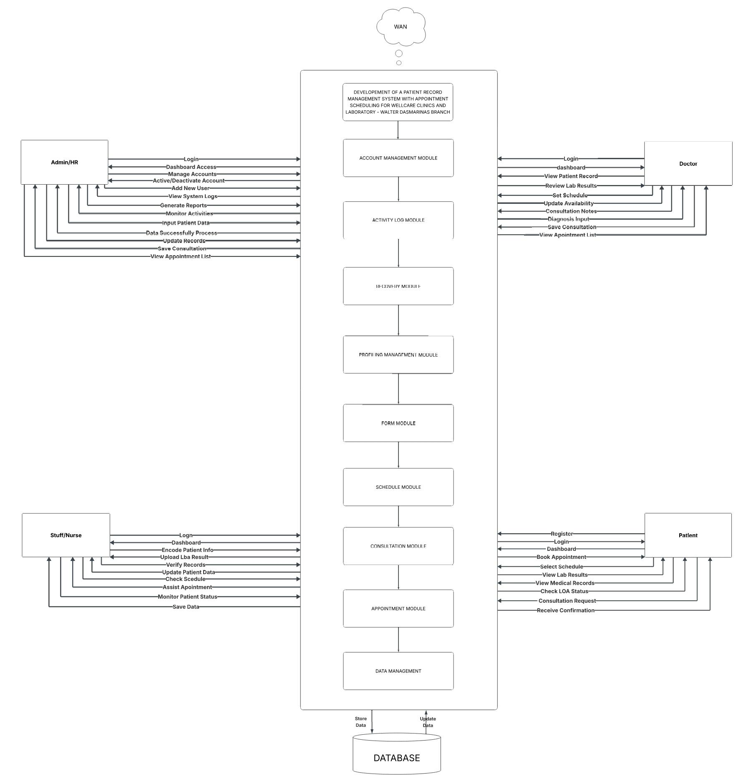

Figure 5 Theoretical Framework of the Development of a patient record management system with appointment booking for wellcare clinics and laboratory- walter dasmarinas branch.
Figure 5 The diagram presents the overall flow of the Patient Record Management System with Appointment Scheduling for Wellcare Clinics. It shows how four main users—Admin/HR, Doctor, Staff/Nurse, and Patient—interact with the system through a centralized database connected via a network.
The process starts when each user logs in and accesses their respective dashboard. From there, they perform specific tasks based on their roles. The Admin/HR manages user accounts, monitors system activities, and generates reports. The Doctor handles consultations by reviewing patient records, checking lab results, setting schedules, and recording diagnoses. The Staff/Nurse is responsible for encoding patient data, verifying records, uploading lab results, and assisting with appointments. Meanwhile, the Patient can register, book appointments, select schedules, and view their medical records and lab results.
All inputs from these users go through different system modules such as appointment, consultation, and scheduling, then are processed and stored in the database. The system continuously updates data, ensuring that all users access accurate and real-time information.
Overall, the flow shows a cycle of input, process, and output, where data is entered, processed through system functions, and then stored or displayed as updated records, confirmations, and reports, supporting efficient clinic operations.

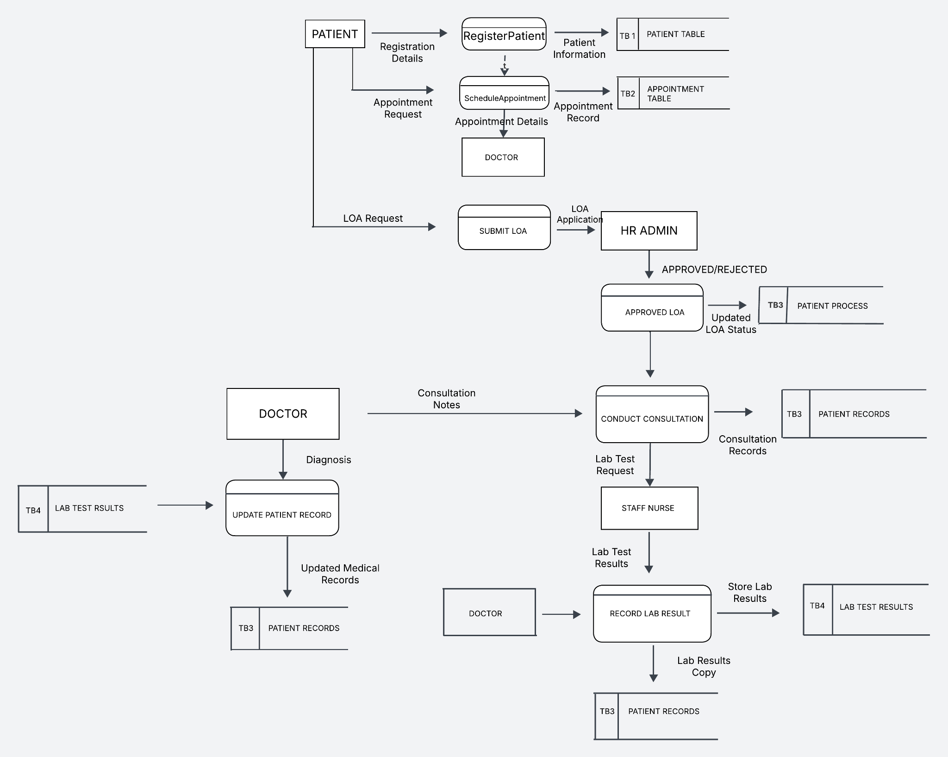
Figure 6 Data Flow Diagram for the Development of a patient record management system with appointment booking for wellcare clinics and laboratory- walter dasmarinas branch.
Figure 6 Shows the Data Flow Diagram (DFD) of the system, illustrating the logical flow of data throughout the patient process. It begins when the Patient submits registration details through the Register Patient process, where the information is stored in the patient database. The patient then requests an appointment through the Schedule Appointment process, where the appointment details are recorded and forwarded to the Doctor for reference. After scheduling, the patient may submit a Letter of Authorization (LOA) request through the Submit LOA process. This request is evaluated by the HR Admin, and the decision (approved or rejected) updates the patient’s record. Once approved, the patient proceeds to the consultation stage. During the consultation, the Doctor records consultation notes through the Conduct Consultation process, which are stored in the patient records. If laboratory tests are required, a request is sent to the Staff Nurse, who processes the test and records the results through the Record Lab Result process. These results are stored and linked to the patient’s records. The Doctor then reviews the lab results and provides a diagnosis through the Update Patient Record process. All updated medical information, including consultation notes and lab results, is saved in the patient records, completing the system’s data flow.

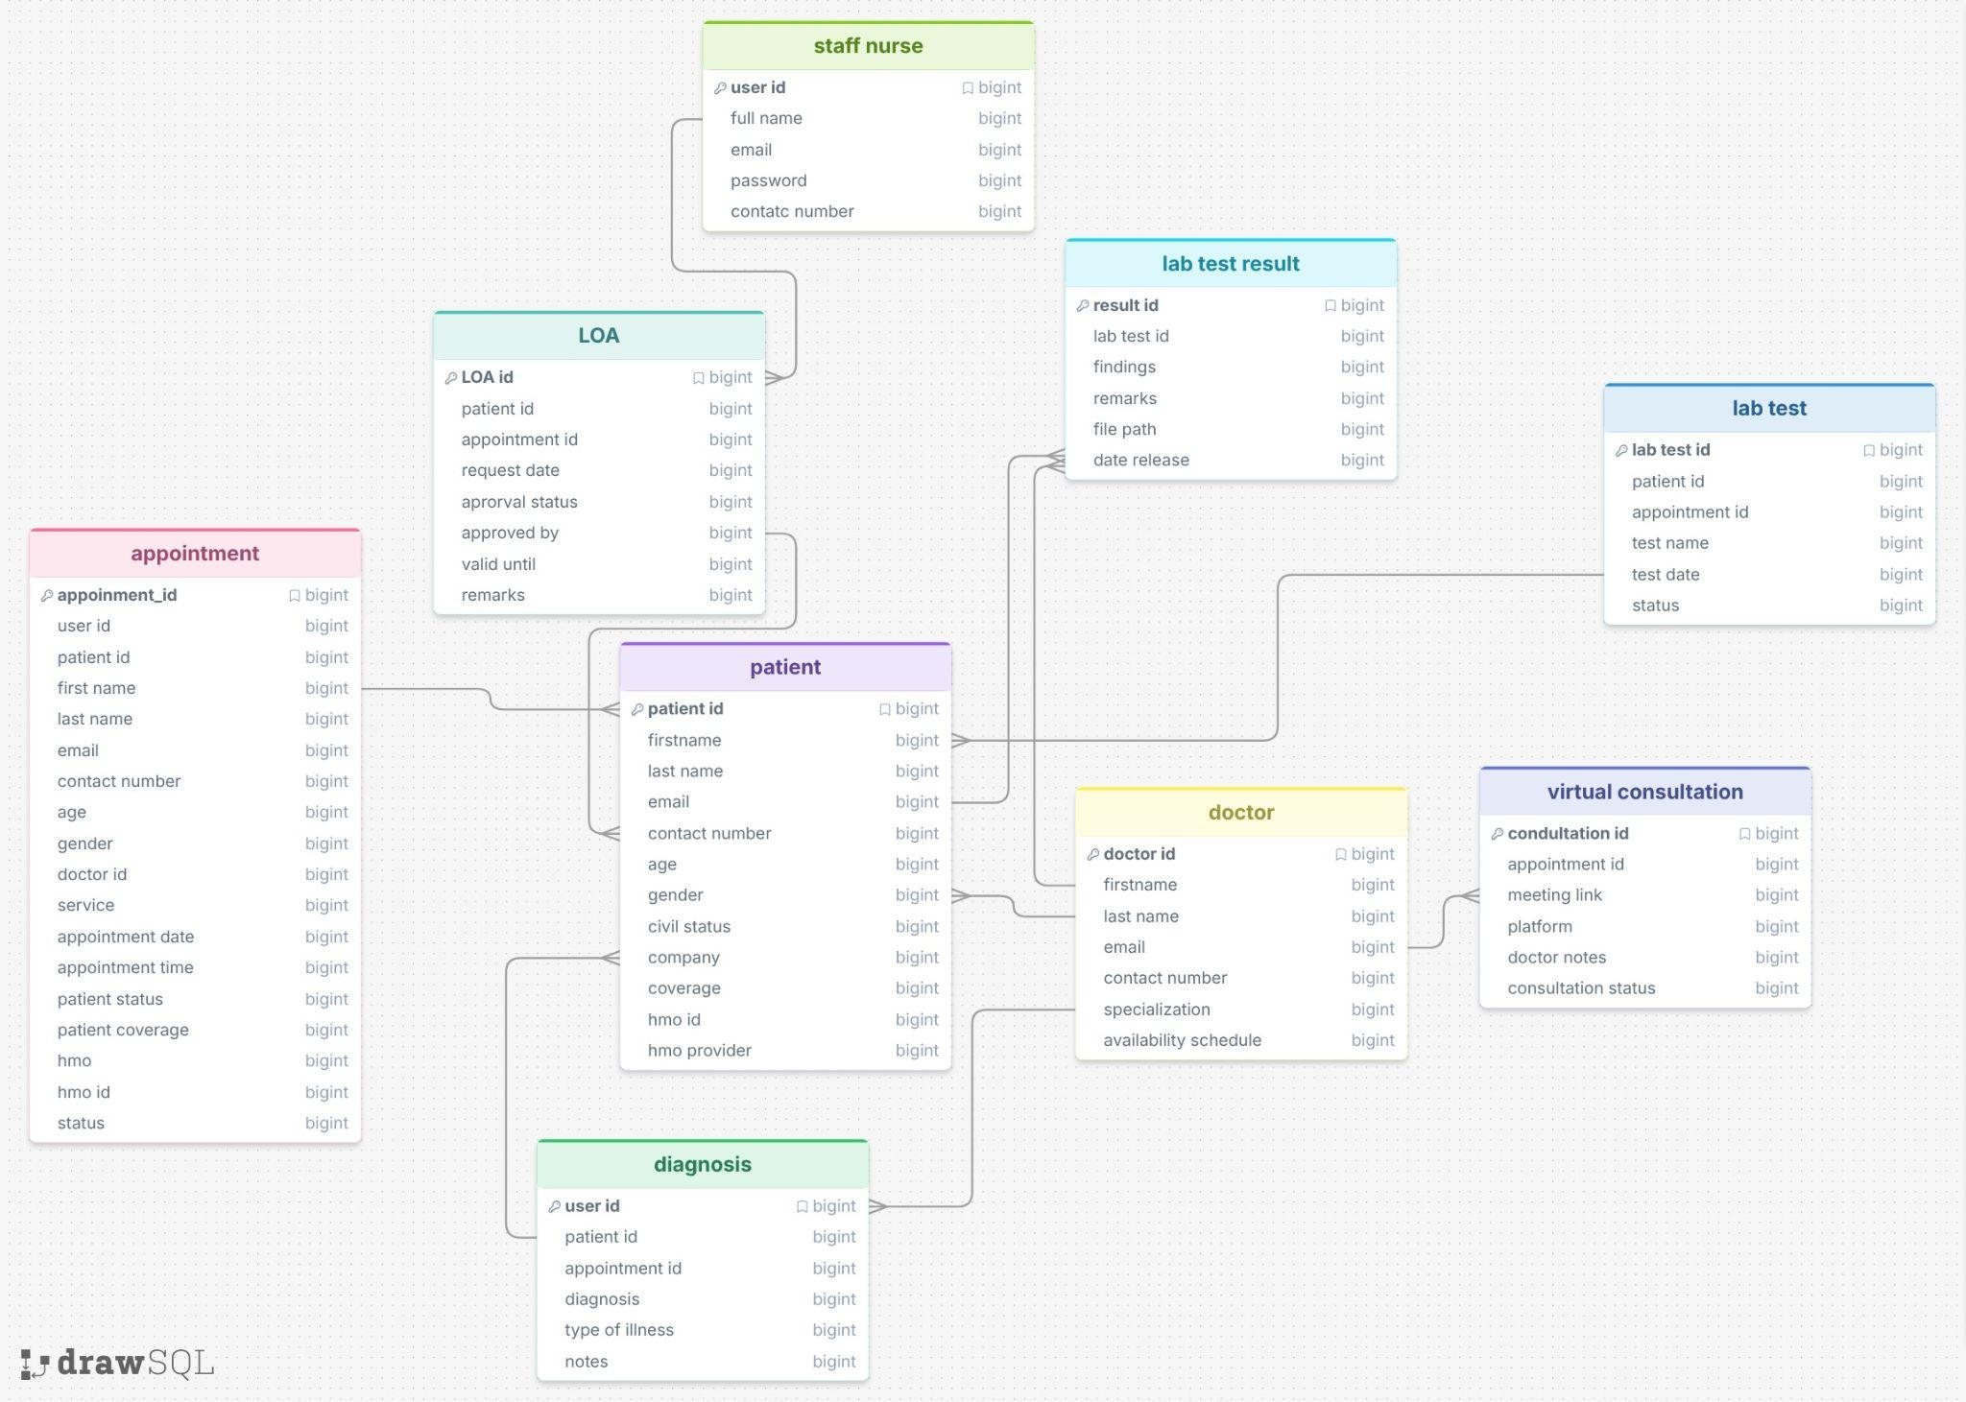

Figure 7 Entity Relationship Diagram (ERD) for the Development of a patient record management system with appointment booking for wellcare clinics and laboratory- walter dasmarinas branch.
Figure 7 shows the Entity Relationship Diagram (ERD) of the system, illustrating how data is logically structured and interconnected. The design centers on a single user account a that serves as the main reference point, linking personal information, medical records, and appointment transactions. Each user is associated with one complete patient profile and one set of medical data, while allowing multiple appointment records to be created under the same account. The relationships are structured to separate different types of data account credentials, personal details, medical information, and appointments while still keeping them connected through key identifiers. This ensures that all patient-related data remains consistent, avoids duplication, and allows efficient retrieval and management of records within the system.
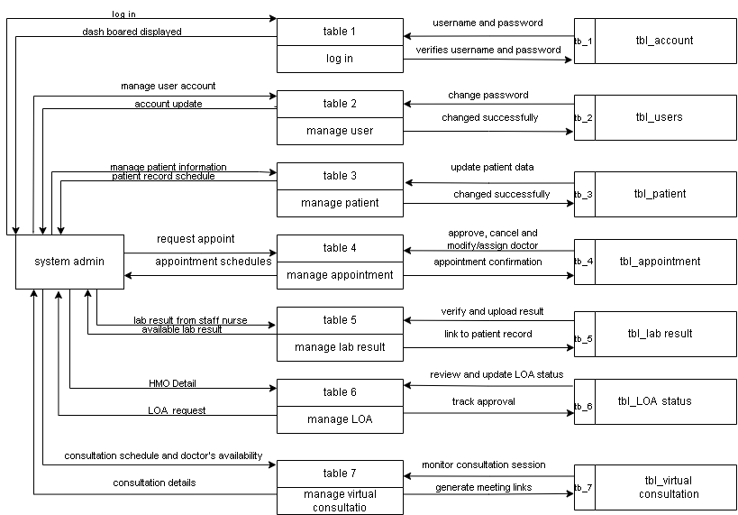
Figure 8 Data flow diagram of system admin for the Development of a patient record management system with appointment booking for wellcare clinics and laboratory- walter dasmarinas branch.
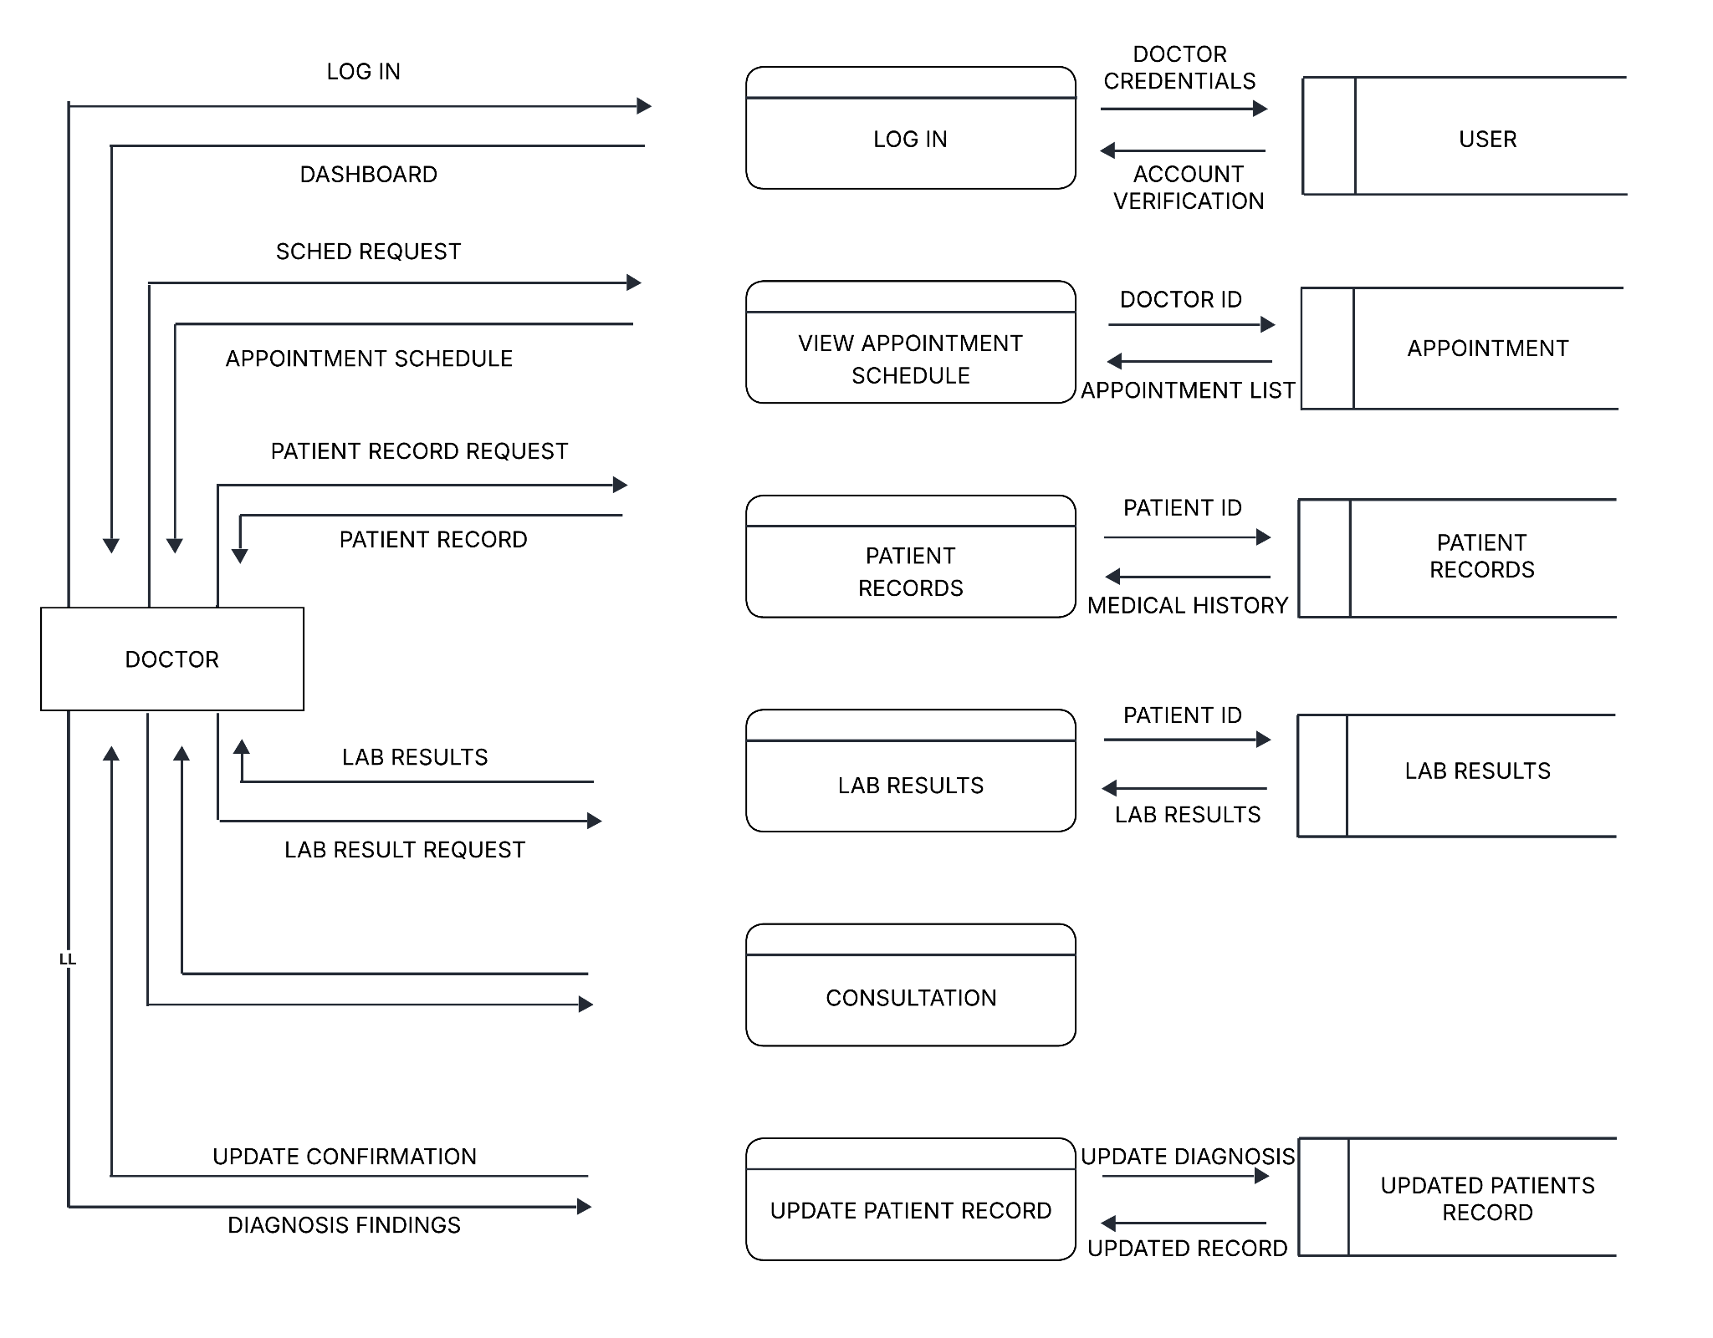
Figure 8 shows the data flow diagram (DFD) for the system administrator shows how data is processed and managed within the system. It begins with the admin logging in using a username and password, which are verified before access to the dashboard is granted. This ensures secure access to system functions. Once logged in, the admin manages user accounts by updating details and passwords, with changes stored in the user database. The admin also handles patient information by updating records and ensuring that all data in the patient database is accurate and up to date.In terms of scheduling, the admin manages appointments by approving, canceling, or modifying requests and assigning doctors when needed. Appointment details are stored in the system for proper tracking. The admin also verifies and uploads laboratory results submitted by staff nurses, linking them to patient records for accuracy. Additionally, the admin processes HMO details and LOA requests by reviewing, updating, and tracking their approval status. Lastly, the admin oversees virtual consultations by monitoring schedules and generating meeting links. Overall, the system administrator ensures efficient, secure, and organized system operations.

Figure 9 Data flow diagram of Doctor for the Development of a patient record management system with appointment booking for wellcare clinics and laboratory- walter dasmarinas branch.
Figure 9 illustrates the Data Flow Diagram (DFD) for the doctor shows how the doctor interacts with the system to manage patient care. The process starts with the doctor logging in using their credentials, which are verified before access to the dashboard is granted. Once logged in, the doctor can view appointment schedules based on their assigned ID, allowing them to manage consultations efficiently. The doctor can also access patient records by requesting patient information, where the system retrieves medical history from the database. In addition, the doctor can request and review laboratory results using the patient ID, which supports accurate diagnosis. During consultation, the doctor records findings and updates the patient’s records. Finally, the updated information is saved in the system, and a confirmation is provided. Overall, the system helps the doctor efficiently handle appointments, review patient data, and update medical records.
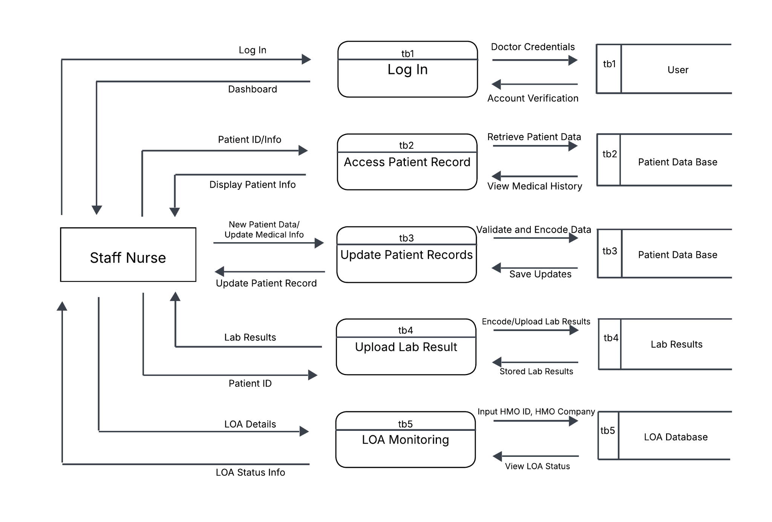
Figure 10 Data Flow Diagram of Staff Nurse for the Development of a patient record management system with appointment booking for wellcare clinics and laboratory- walter dasmarinas branch.
Figure 10 shows the DFD for the staff nurse shows how the nurse logs in, with credentials verified before accessing the system. The nurse can view medical history, and update patient information, which is then saved in the database. The nurse also uploads lab results linked to the patient and monitors LOA by entering HMO details and checking approval status. Overall, the system allows the staff nurse to efficiently manage patient data, lab results, and LOA information.
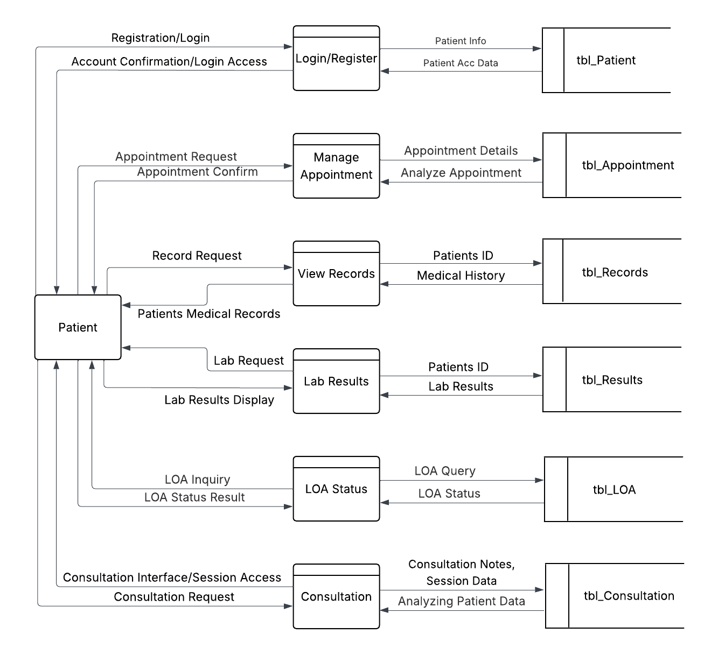
Figure 11 Data Flow Diagram of Patientfor the Development of a patient record management system with appointment booking for wellcare clinics and laboratory- walter dasmarinas branch.

Figure 11 illustrates the DFD for the patient shows how the patient registers or logs in, with account credentials verified before gaining access to the system. Once logged in, the patient can request and manage appointments, which are processed by the system and stored in the database for scheduling and confirmation. The patient can also view medical records by sending a request, allowing the system to retrieve and display their medical history. In addition, the patient may request laboratory services and view lab results, which are stored and accessed through the system. The patient can also inquire about LOA status by submitting a request, where the system processes the query and provides updates from the database. Furthermore, the patient is able to access consultation services by initiating consultation requests and participating in sessions. Overall, the system allows the patient to efficiently manage appointments, access medical records and lab results, monitor LOA status, and engage in consultations.
Systems Requirements
Table 1 hardware requirementsTable 2 Software Requirements
Operating Systems | Windows 10 Pro
Processing Unit | intel(R) core(TM) i5-6200U
Random Access Memory (RAM | 8.00 GB
Read-Only Memory (ROM) | 128GB

 | React TypeScript used to develop the user interface, including modules for appointment scheduling, patient registration, record viewing, and dashboard navigation. It manages user inputs, displays available schedules, and allows users to review and confirm their data before submission.
 | Laravel is an open-source PHP web application framework used to build modern, secure, and scalable web systems. It follows the Model–View–Controller (MVC) architectural pattern, which separates application logic, user interface, and data handling to make development organized and maintainable.
 | MySQL is being used to store and organize system data, including patient records, appointments, laboratory results, and user accounts. Data relationships are being structured to connect patient information with their medical history and transactions.
 | CSS (Cascading Style Sheets) is used to style and format HTML content. Tailwind CSS is a utility-first CSS framework that provides pre-designed classes for building responsive and visually consistent interfaces quickly and efficiently.

System Design
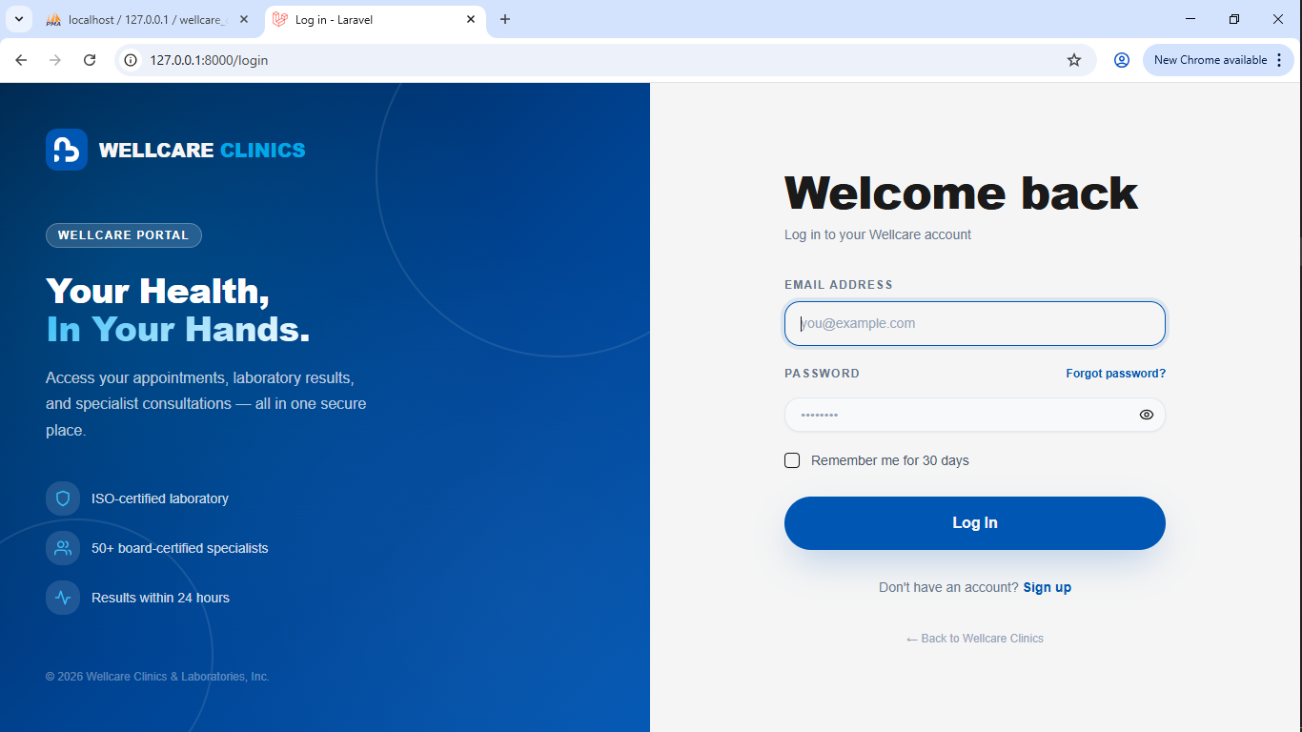
User Interface Design

Figure 12 Log-in form of the System
Figure 12 shows the login interface for “Wellcare Clinics Patient Portal” featuring fields for email and password, options to remember the user and reset a forgotten password, and buttons to log in or sign in. It also includes a prompt for new users to sign up.

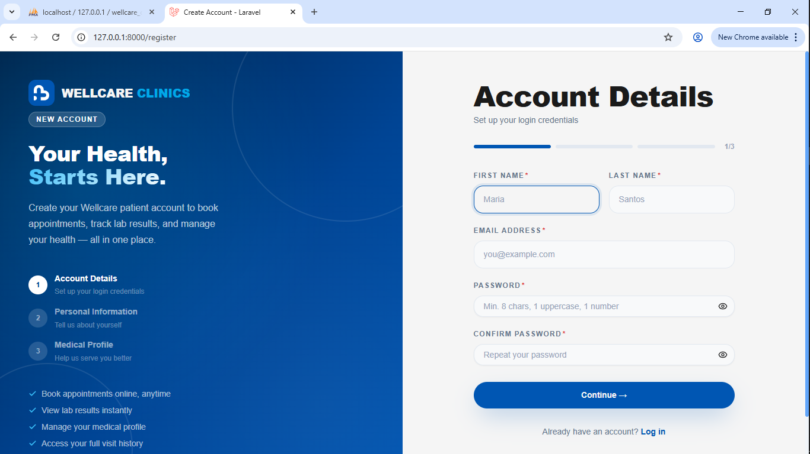
Figure 13 Sign-up Form of the System
Figure 13 shows the user registration page for “Wellcare Clinics Patient Portal” with fields for first name, last name, email, password, and password confirmation.
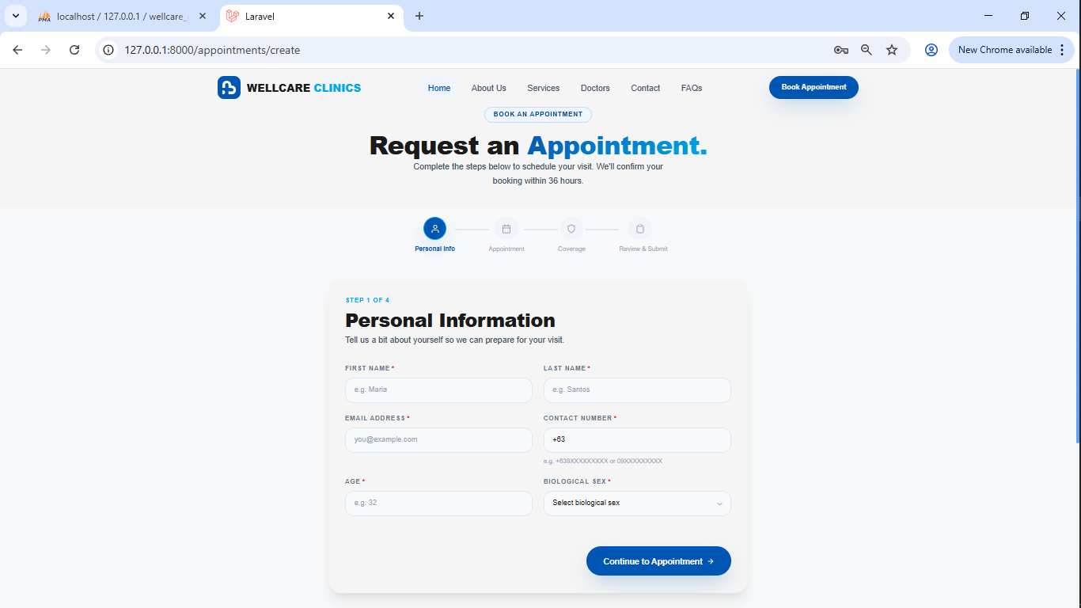

Figure 14 Request Appointment of the System
Figure 14 shows the personal information for requesting an appointment for “Wellcare Clinics Patient Portal” with fields of first name, last name, email, number, and age, and also includes the selection of biological sex
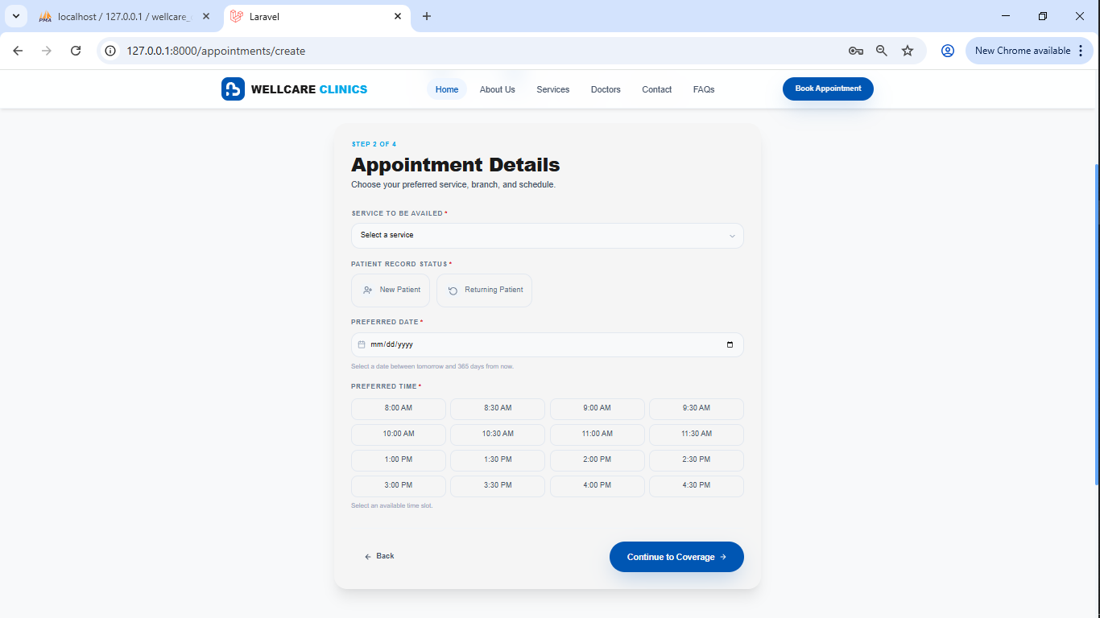

Figure 15 Appointment Details of the System
Figure 15 shows the appointment details inputted in the personal information page requesting an appointment, with the fields of selecting a service, patient record status, and preferred time and date.

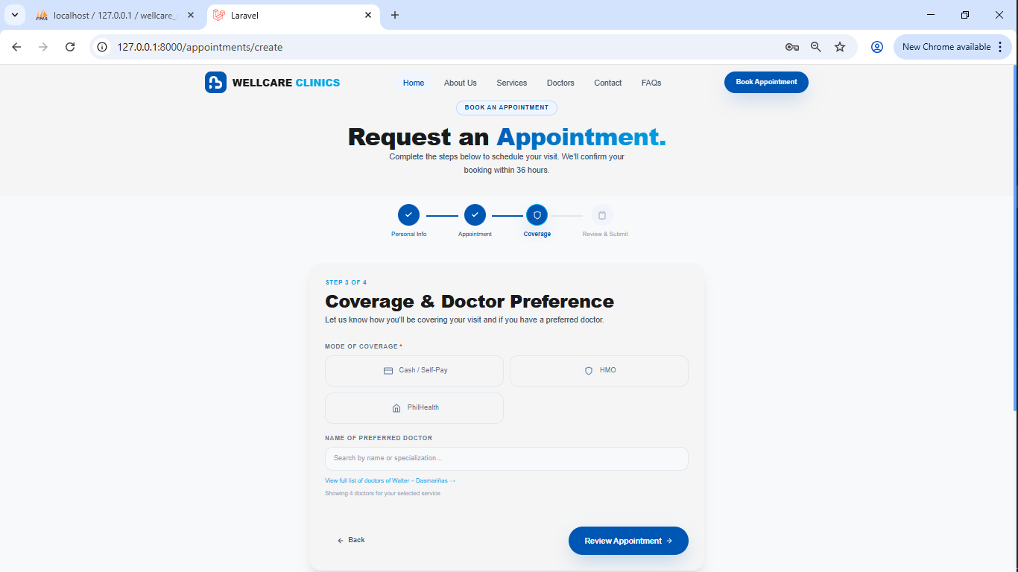

Figure 16 Coverage and Doctor Preference of the System
Figure 16 shows the Coverage and Doctor Preference section of the appointment request process in the system. This interface allows the user to specify how the consultation will be covered and to select a preferred doctor. The fields include the Mode of Coverage, where the user can choose between options such as Cash/Self-pay, HMO, and PhilHealth, and the Name of Preferred Doctor, where the user can search or input a doctor’s name. This page also provides navigation buttons such as Back and Review Appointment to proceed to the next step or return to the previous section.

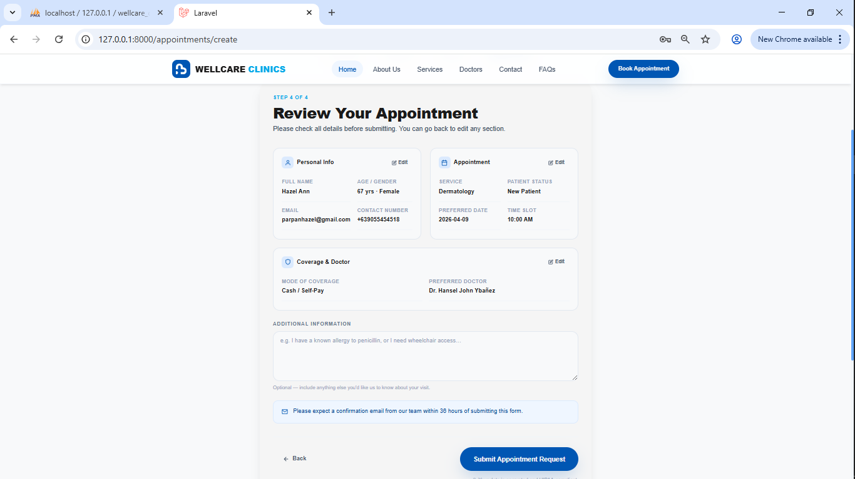
Figure 17 Reviewing Patient Appointment of the System

Figure 17 shows the Reviewing Patient Appointment section of the system. This interface allows the user to review and confirm all entered details before submitting the request. It includes Personal Information (name, age, gender, email, and contact number), Appointment Details (service, patient status, date, and time), and Coverage & Doctor (mode of payment and preferred doctor). An Additional Information field is also provided for notes or special concerns. Navigation buttons such as Back and Submit Appointment Request are available to either return to the previous step or finalize the appointment.

System Development
The system development focuses on the implementation of the Web-Based Patient Record Management System with Appointment Scheduling, which is currently under development. The system is being developed using Laravel as the primary framework, integrated with React TypeScript for the frontend, Tailwind CSS for interface design, and MySQL for data management. These technologies are being structured to support the system’s core modules and ensure consistency with the defined system requirements.
Laravel, running on PHP 8.2, is being used as the main backend framework responsible for handling core system operations such as user authentication, appointment validation, record processing, and LOA tracking. It is managing server-side logic and ensuring that appointment requests are being validated to prevent scheduling conflicts before confirmation. Laravel is also serving as the central integration layer that connects all system components.
React with TypeScript is being utilized for developing the system’s user interface. It is handling interactive components such as appointment scheduling, patient registration, record viewing, and dashboard navigation. The use of TypeScript is helping improve code structure and maintainability, while Tailwind CSS is being applied to create a responsive, consistent, and user-friendly interface across all modules.
The frontend and backend integration is being handled within the Laravel environment, where supporting tools such as Inertia.js and Vite are being utilized to enable seamless page rendering and efficient asset management. NPM is being used to manage frontend dependencies and required packages for React and Tailwind, ensuring an organized and optimized development workflow. These tools are configured as part of the Laravel setup, allowing the system to function as a unified application.
MySQL is being used as the database management system to store and organize system data, including patient records, appointments, laboratory results, and user accounts. Data relationships are being structured to ensure proper linkage between patient information, medical history, transactions, and system activities.
These technologies are being applied across the system’s key features:
Appointment Scheduling – React with TypeScript is handling user input and interface interaction, Laravel is processing and validating scheduling logic, and MySQL is storing booking data
Patient Record Management – React is presenting patient data, Laravel is processing and retrieving records, and MySQL is managing structured storage
Laboratory Results – React is displaying results, Laravel is retrieving data, and MySQL is storing diagnostic information
LOA Tracking – React is showing status updates, Laravel is processing LOA requests, and MySQL is maintaining tracking records
User Management – Laravel is managing authentication and access control, React is handling the interface, and MySQL is storing user credentials
All components are being integrated within the Laravel framework, allowing smooth data flow between the user interface and the database. This architecture is supporting system functionalities such as appointment confirmation, record retrieval, real-time updates, and status monitoring.
Overall, the system is still under development, and the implemented features are representing the initial working components that are being continuously improved and refined in the succeeding development phase.
System Testing Procedure
Unit Testing — conducted to verify that individual modules of the Web-Based Patient Record Management System with Appointment Scheduling function correctly. Each component, such as user login and authentication, patient registration, appointment scheduling, patient record management, laboratory results, online consultation, and user management, is tested independently using valid and invalid inputs to ensure accurate data processing and proper validation.
This testing covers functionalities for different system users, including patients, doctors, nurses, and HR/Admin, ensuring that each role can perform its specific tasks correctly within the system. It also helps identify and resolve errors early in development, improving the overall reliability and stability of the system before integration.
Table 3 Unit Testing for Patients
Test Case | Expected Result | Test Result
Patient account registration | Account successfully created | Pass
Login patient account | Patient dashboard displayed | Pass
Invalid login | Error message displayed | Pass
View patient records | Patient dashboard displayed | Pass
Book appointment | Appointment successfully scheduled | Pass
Book overlapping appointment | Error: schedule conflict | Pass
View laboratory results | Lab results displayed | Pass
Check LOA status | LOA status displayed | Pass
Update personal information | Information successfully updated | Pass
Access online consultation feature | Consultation interface displayed | Pass
Start consultation session | Video/consultation session starts successfully | Pass
End consultation session | Consultation session terminated successfully | Pass
Logout | Patient logged out and redirected to login page | Pass

table 4 Unit Testing for Doctor Module
Test Case | Expected Result | Test Result
Doctor login | Doctor dashboard displayed | Pass
View patient records | Complete patient history displayed | Pass
View appointment schedule | List of scheduled patients displayed | Pass
Access online consultation interface | Consultation dashboard displayed | Pass
Accept patient consultation request | Consultation session initiated | Pass
Start consultation session | Session starts successfully | Pass
End consultation session | Session terminated successfully | Pass
Attempt consultation without schedule | Error or restriction message displayed | Pass
Logout | Doctor logged out successfully | Pass

table 5 Unit Testing for Staff/Nurse Module
Test Case | Expected Result | Test Result
Staff/Nurse login | Staff/Nurse dashboard displayed | Pass
View patient records | Patient information displayed | Pass
Update patient records | Patient record updated successfully | Pass
Released laboratory results | Results uploaded | Pass
Monitor daily appointments | Appointment list displayed | Pass
Verify patient information | Verified and confirmed patient details | Pass
Invalid data entry | Validation error message displayed | Pass
Logout | Staff/Nurse logged out successfully | Pass

table 6 Unit Testing for HR Module
Test Case | Expected Result | Test Result
Admin/HR login | Admin dashboard displayed | Pass
Invalid login | Error message displayed | Pass
Create user account (staff/doctor) | User account successfully created | Pass
Update user account | User details updated successfully | Pass
Delete user account | User account removed from system | Pass
Manage appointment schedules | Updated appointment schedule reflected | Pass
Monitor daily appointments | List of all scheduled appointments displayed | Pass
View LOA request | LOA request information displayed | Pass
Send LOA request to HMO via email | Email successfully sent to HMO | Pass
Record LOA response from HMO | LOA status updated based on HMO response | Pass
View patient records (restricted access) | Patient information displayed with limited access | Pass
Generate reports | Report generated and displayed/exported | Pass
Unauthorized access attempt | Access denied message | Pass
Logout | Admin logged out successfully | Pass

Integration Testing — performed to ensure that the different modules of the system work together properly. It focuses on verifying data flow and interaction between components, such as linking patient registration to the database, connecting appointments to patient records, and integrating laboratory results and consultation features. This phase ensures that all modules communicate effectively without errors.
table 7 Integration of the Patient Record Management System with Appointment Scheduling for Wellcare Clinics and Laboratory – WalterMart Dasmariñas Branch.
Test Case | Functionality | Test Result | Remarks
Patient Registration to Database Integration | Ensures that patient information entered during registration is accurately stored and retrieved from the database |  | All patient data is successfully saved and reflected across the system modules
Patient Registration to Appointment Scheduling | Handles integration between patient accounts and appointment booking |  | Patient information is automatically linked during appointment creation
Appointment Scheduling to Patient Records | Ensures that scheduled appointments are recorded in the patient’s medical history |  | Appointments are correctly displayed in patient records without errors
Laboratory Results Upload to Patient Portal | Manages uploading of laboratory results and patient access |  | Patients can view accurate and updated laboratory results in real time
Laboratory Results to Doctor Module | Allows doctors to access and review laboratory results |  | Laboratory data is properly synchronized and accessible to doctors
Patient Records to Consultation Module | Ensures consultation notes are recorded and linked to patient profiles |  | Consultation details are stored accurately within patient records
Online Consultation Integration | Handles interaction between online consultation and patient records |  | Online consultation data is successfully recorded and retrievable
HR/Admin to LOA Monitoring | Manages LOA status updates and synchronization with patient view |  | LOA status updates are correctly reflected in the patient portal
User Roles and Access Control Integration | Handles role-based access for Admin, Doctor, Nurse, and Patient |  | All user roles have appropriate permissions and restrictions
Dashboard Integration | Ensures dashboard displays real-time data from all modules |  | Dashboard information is accurate and consistently updated

System Testing — evaluate the complete and fully integrated system in a real-world environment. It assesses the system’s functionality, usability, performance, security, and compatibility. Test scenarios include patient registration, appointment booking, record management, laboratory result access, and online consultation. This ensures that the system meets all requirements and is ready for deployment.
table 8 System Testing of the Patient Record Management System with Appointment Scheduling for Wellcare Clinics and Laboratory – WalterMart Dasmariñas Branch.
Test Case Title | Activities | System Response | Expected Error | System Response
Patient Registration | Enter patient details and submit registration form | System saves patient information and creates user account | Invalid or incomplete input data | System displays validation errors and prevents submission
User Login and Authentication | Enter valid and invalid login credentials | System grants access for valid users and redirects to dashboard | Incorrect username/password | System displays error message and denies access
Appointment Booking | Patient selects date and books appointment | Appointment is successfully scheduled and recorded | Double booking or invalid schedule | System prevents booking and shows conflict message
Patient Record Management | View and update patient records | System displays and updates patient information correctly | Unauthorized access attempt | System restricts access based on user role
Laboratory Result Access | Patient views uploaded lab results | System displays accurate laboratory results | No available lab results | System shows “No results available” message
Laboratory Result Upload | Nurse uploads laboratory results | System stores and links results to patient profile | Incorrect file or missing data | System prompts error and rejects upload
Online Consultation | Patient and doctor conduct online consultation | System allows communication and records consultation details | Connection failure or session error | System displays connection error and prompts retry
LOA Monitoring (HR/Admin) | HR updates LOA status | System reflects updated LOA status in patient account | Invalid or missing LOA data | System displays error and prevents update
Dashboard Functionality | Access system dashboard | System displays real-time summary of data (patients, appointments, results) | Data loading failure | System shows error or reload prompt
Role-Based Access Control | Login as Admin, Doctor, Nurse, Patient | System restricts access based on assigned role | Unauthorized module access | System denies access and shows warning
System Performance | Perform multiple transactions simultaneously | System processes requests efficiently without delay | System overload or slow response | System shows delay or timeout message
System Security | Attempt unauthorized data access | System protects data and blocks unauthorized actions | Security breach attempt | System logs activity and denies access
Compatibility Testing | Access system using different browsers/devices | System functions consistently across platforms | Browser incompatibility | System may display layout or functionality issues

System Evaluation Procedures
The system evaluation procedures were conducted to assess the overall quality and performance of the Patient Record Management System with Appointment Scheduling using selected criteria from ISO/IEC 25010. The evaluation focused on functional suitability, usability, performance efficiency, security, and compatibility to ensure that the system meets the operational needs of the clinic.
Selected evaluators, including patients, doctors, nurses, and admin/HR staff, were given access to the system and performed actual tasks such as registration, appointment booking, record management, and online consultation. After using the system, they completed a structured questionnaire to measure their experience and satisfaction. The collected responses were analyzed to determine the system’s level of acceptability and readiness for deployment.
The applicable criteria used in this study included:
Functional Suitability — Evaluates if the system correctly performs key functions such as patient registration, appointment scheduling, record management, laboratory results access, and online consultation.
Usability — Measures how easy and user-friendly the system is for patients, doctors, nurses, and admin/HR in performing their tasks.
Performance Efficiency — Assesses how quickly and efficiently the system processes data and responds to user actions.
Security — Ensures that patient data is protected through role-based access and prevention of unauthorized access.
Compatibility — Determines if the system works properly across different devices, browsers, and operating systems.

References
Bruno, B., Steele, S., Carbone, J., Schneider, K., Posk, L., & Rose, S. L. (2022). Informed or anxious: Patient preferences for release of test results of increasing sensitivity on electronic patient portals. Health and Technology, 12(1), 59–67. https://doi.org/10.1007/s12553-021-00628-5⁠�
Use and experiences with patient portals among older adults. (2023, May). backend.production.deepblue-documents.lib.umich.edu. Retrieved March 8, 2026, from https://backend.production.deepblue-documents.lib.umich.edu/server/api/core/bitstreams/17c2c33b-52a4-4dda-b532-aec7ae5554ff/content JMIR Article
Simola, S., Hörhammer, I., Xu, Y., Bärkås, A., Fagerlund, A. J., Hagström, J., Holmroos, M., Hägglund, M., Johansen, M. A., Kane, B., Kharko, A., Scandurra, I., & Kujala, S. (2023). Patients’ experiences of a national patient portal and its usability: Cross-sectional survey study. Journal of Medical Internet Research, 25, e45974. https://doi.org/10.2196/45974
Nagler, King, A. , W., R. (n.d.). Patient portal messaging to address delayed follow-up for uncontrolled diabetes: a pragmatic, randomised clinical trial. qualitysafety.bmj.com. JAMA Network Open
Gleason, K. T., Peereboom, D., Wec, A., & Wolff, J. L. (n.d.). Patient Portals to Support Care Partner Engagement in Adolescent and Adult Populations. JAMA Network Open. https://doi.org/10.1001/jamanetworkopen.2022.486966. ASCO (JCO Clinical Cancer Informatics)
Green, A. R., Wec, A., Gleason, K. T., Gamper, M. J., Wu, M. M. J., & Wolff, J. L. (2024). Use of the Patient Portal to Discuss Medications Among People with Dementia and Their Care Partners. Journal of General Internal Medicine, 39(16), 3164–3171. https://doi.org/10.1007/s11606-024-09064-37. PubMed Central Article
Sisk, B. A., Bereitschaft, C., Enloe, M., Schulz, G., Mack, J., & DuBois, J. (2023). Oncology clinicians’ perspectives on online patient portal use in pediatric and adolescent cancer. JCO Clinical Cancer Informatics, 7(7), e2300124. https://doi.org/10.1200/cci.23.00124
Yarima, et al. (2024). Development and implementation of a new patient appointment scheduling system at Adustech Wudil: An evaluation of user satisfaction and system impact.
https://repo.uum.edu.my/id/eprint/32346/
Semantha, F. H., Azam, S., Shanmugam, B., Yeo, K. C., & Beeravolu, A. R. (2021). A conceptual framework to ensure privacy in patient record management system. IEEE Access.
https://ieeexplore.ieee.org/abstract/document/9646903/
Alsuyof, A., Ishak, A. K., Lutfi, A., Nasser, F., Alhazmi, A., & Al-Okaily, M. (2022). The role of personality and top management support in continuance intention to use electronic health record systems among nurses. International Journal of Environmental Research and Public Health.
https://www.mdpi.com/1660-4601/19/17/11125

Wu, Z., & Trigo, V. (2021). Impact of information system integration on healthcare management and medical services.https://www.tandfonline.com/doi/abs/10.1080/20479700.2020.1760015
Kalarani, et al. (2025). A secure and cloud-based patient management system using attribute-based encryption algorithm. https://www.academia.edu/download/121324425/106_35790_IJECE_11_Iq.pdf
Yarima, K. I., Lawan, A. A., Umar, I. A., Uba, H. U., & Haruna, Y. (2024). Development and implementation of a new patient appointment scheduling system at ADUSTECH Wudil: An evaluation of user satisfaction and system impact. Journal of Computational Innovation and Analytics, 3(2), 27–56. https://doi.org/10.32890/jcia2024.3.2.2
Kumar, R., Shadheem, S., & Surya, S. (2024). Web-based application for doctor-patient appointment management system. IRO Journal of Intelligent Systems and Machine Computing, 6(3), 261–270. https://doi.org/10.36548/jismac.2024.3.006

